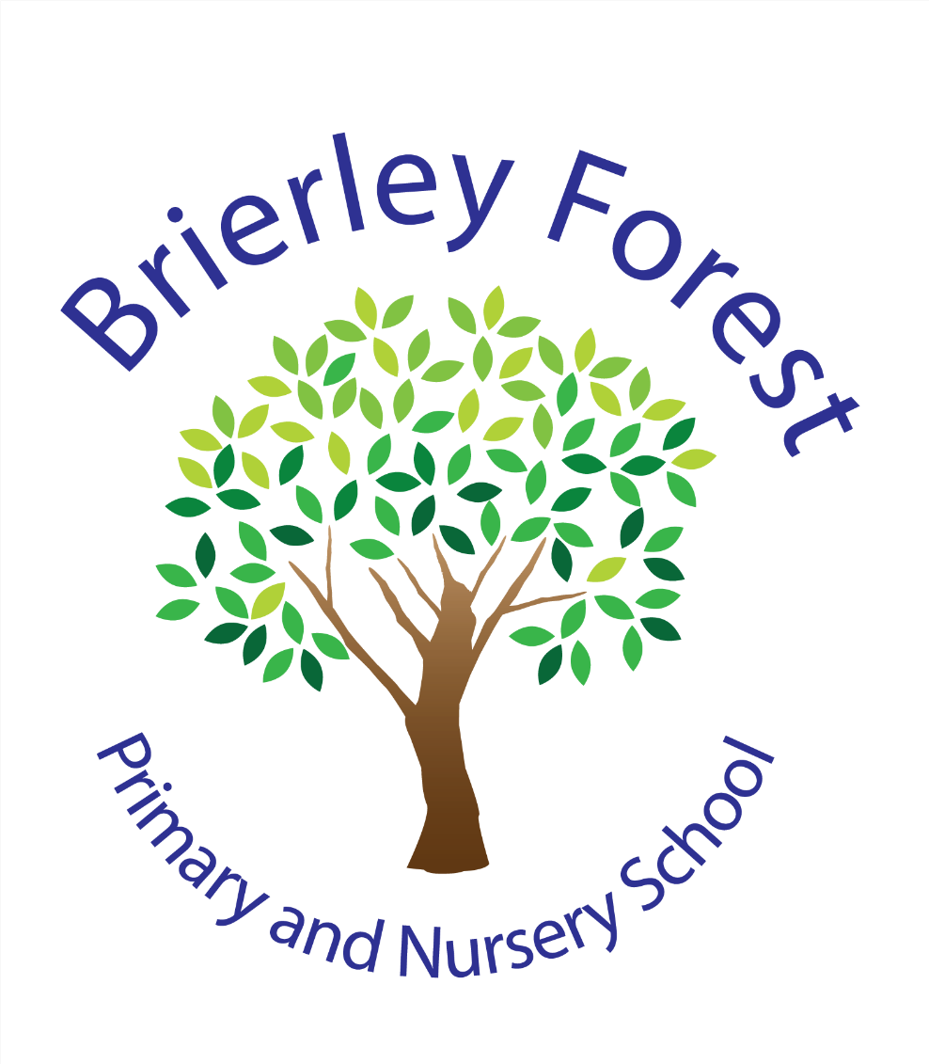

Brierley Forest Primary and Nursery School
Accessibility Plan
2026-27



Brierley Forest Primary and Nursery School

Accessibility Plan 2026-27
At Brierley Forest Primary and Nursery School, we are committed to creating an inclusive environment where every child feels valued, supported and able to participate fully in school life.
We believe that all children should have equal opportunities to learn, achieve and develop independence, regardless of any disability, medical need or additional need. We work closely with families, pupils and external professionals to identify and remove barriers to learning and participation wherever possible. [

Our Commitment to Inclusion
Our school values are built around a strong sense of belonging. We aim to ensure that:
- Every child feels welcome and included.
- Children are treated fairly and with respect.
- Individual strengths and needs are recognised.
- Appropriate support and adaptations are provided where needed.
- All pupils can access learning, school activities and enrichment opportunities.
- Parents and carers are involved in decisions about their child's support.

What is an Accessibility Plan?
The Accessibility Plan explains how Brierley Forest Primary and Nursery School works to improve access for pupils, parents, carers, staff and visitors with disabilities.
The plan is guided by the Equality Act 2010 and focuses on three key areas:
- Increasing access to the curriculum.
- Improving the physical environment.
- Improving access to information and communication.

What Do We Mean by Disability?
Under the Equality Act 2010, a disability is a physical or mental impairment that has a substantial and long-term effect on a person's ability to carry out everyday activities.

How We Support Accessibility at Brierley Forest
We work closely with children, families and outside agencies to identify any barriers and make reasonable adjustments to support full participation in school life. These adjustments are reviewed regularly and adapted when needed.

Our School Environment
We are fortunate to have a school building that is accessible to pupils and adults with a range of needs.
Current accessibility features include:
- Accessible entrances and pathways.
- Wheelchair-accessible classrooms and facilities.
- An internal lift providing access between floors.
- Ramps and handrails where required.
- Accessible outdoor spaces.
- Clear signage around the school site.
The school regularly reviews the site to ensure facilities remain safe, accessible and fit for purpose.

Supporting Pupils with Medical Needs and Disabilities
We support children with a wide range of needs, including:
- Autism Spectrum Condition (ASC).
- Visual impairments.
- Hearing impairments.
- Mobility difficulties.
- Medical conditions such as asthma.
- Allergies and food intolerances.
- Other significant health needs.
Where specialist advice is required, we work with Local Authority services, health professionals and external agencies to ensure appropriate support is in place.

Medication and Medical Support
- Individual medical needs are shared with relevant staff.
- Medication is stored securely.
- Written parental consent is obtained before administering medication.
- Records are kept of all medication administered.
- Qualified First Aiders and Paediatric First Aiders are available within school.

Accessibility Priorities for 2026-27

1. Equality and Inclusion

What we will do
- Review the Accessibility Plan annually with Governors.
- Ensure staff receive appropriate training on disability awareness and inclusive practice.
- Consider accessibility requirements whenever school policies are reviewed.
- Promote positive attitudes towards disability and diversity throughout school.

What we hope to achieve
- A fully inclusive school community.
- Increased awareness and understanding of disability.
- Policies that reflect current legislation and best practice.

2. Physical Environment

What we will do
- Continue to review accessibility whenever building improvements are planned.
- Maintain ramps, lifts, pathways, handrails and signage.
- Consider accessibility when developing indoor and outdoor learning spaces.
- Ensure all pupils and visitors can move around the site safely wherever possible.

What we hope to achieve
- A safe and accessible environment for all members of the school community.
- Continued compliance with accessibility requirements.

3. Access to Learning

What we will do
- Provide ongoing staff training to support children with SEND and disabilities.
- Adapt teaching and learning so all pupils can access the curriculum.
- Ensure children can participate in trips, clubs, visits and enrichment opportunities wherever it is safe and appropriate to do so.
- Use specialist resources and equipment when needed.
Examples may include:
- Pencil grips.
- Writing slopes.
- Specialist seating.
- Noise-cancelling headphones.
- Hearing support equipment.
- Visual supports.
- Toileting aids.
- Specialist reading resources.

What we hope to achieve
- Improved independence.
- Full participation in learning.
- Reduced barriers to achievement.
- Positive experiences in all areas of school life.

4. Assessments and National Tests
Where appropriate, pupils will receive access arrangements that reflect their usual classroom support.
These may include:
- Additional time.
- Rest breaks.
- Adapted resources.
- Specialist equipment.
- Other approved adjustments.

What we hope to achieve
- Fair access to assessments.
- Opportunities for pupils to demonstrate their knowledge and skills successfully.

5. Communication with Families
We are committed to ensuring that information is accessible to all parents and carers.
Where needed, we can provide:
- Telephone appointments.
- Microsoft Teams meetings.
- Alternative methods of communication.
- Written information in accessible formats where possible.
We encourage parents to contact school if they require information in a different format or need additional support to access meetings and school events.

Working Together
We believe that the best outcomes are achieved when schools, families and professionals work together. Parents and carers are encouraged to:
- Share information about their child's needs.
- Attend meetings and reviews where possible.
- Raise concerns or questions promptly.
- Work alongside school staff to support their child's development and wellbeing.
Together, we can ensure that all children are able to thrive and reach their full potential at Brierley Forest Primary and Nursery School.
Policy Date: September 2026
Review Date: September 2027
Responsible Committee: Governing Body – Grace Walters
School Lead: Inclusion Team

What we want to achieve | Why this is important | What we will do
Create an inclusive community | Children, parents, staff and visitors should be able to participate fully in school life. | Review accessibility and inclusion each year with governors, ensure policies consider accessibility needs, and provide staff training to improve understanding of disabilities and additional needs.
Provide consistent expectations and routines | Children learn best when expectations are clear and predictable. | Use whole-school behaviour expectations, positive praise and rewards, and ensure all staff apply approaches consistently.
Create accessible and supportive environments | Some children may find busy, noisy or disorganised environments difficult to manage. | Plan calm learning environments, use quality first teaching, organise classrooms carefully, and provide support and guidance to staff where needed.
Ensure learning is effectively pitched | Children need learning to be adapted so they can participate, succeed and make progress. | Adapt teaching to children's starting points, provide appropriate support, and use individual learning plans or healthcare plans where required.
Meet individual SEND needs | Children with SEND may require specific support to access learning and school activities. | Provide staff training, monitor needs regularly, follow the graduated approach, and work alongside external professionals where appropriate.
Provide equipment to identified need | Some children need additional equipment to access learning independently. | Supply equipment such as pencil grips, writing slopes, specialist seating, hearing support equipment, visual resources, noise-reducing headphones and toileting aids when required.
Support communication and language needs | Children with speech, language, communication needs or English as an Additional Language may need information presented differently. | Use visual timetables, signs, symbols, communication aids, EAL support strategies and advice from Speech and Language Therapists.
Ensure learning materials are accessible for all | Some children and families may require different formats to access information. | Use symbols, adapted print sizes, coloured overlays or paper, translated or explained information, and specialist advice for visual impairments when needed.
Maintain a safe and accessible site | Buildings and school grounds should be safe and accessible for everyone. | Consider accessibility when making building improvements and maintain ramps, handrails, pathways, lifts, signage and other accessibility features.
Support those with impairments to participate alongside their peers | Difficulties with hearing, sight or sensory processing can affect learning and participation. | Monitor needs, involve parents and specialists, provide appropriate equipment and ensure suitable seating and classroom arrangements.
Listen to children's voices | Children should be able to share their views and feel that they are heard. | Use wellbeing surveys, pastoral support and individual discussions to understand children's experiences and needs.
Ensure all children can take part in enrichment opportunities. | Every child should have equal access to clubs, trips, visits and enrichment activities where it is safe to do so. | Review activities to remove barriers and make reasonable adjustments where needed.
Support children during national assessments | Some children require adaptations to demonstrate what they know and can do. | Apply for access arrangements and provide additional time, adapted resources or other approved support in line with normal classroom practice.
Work in partnership with parents and carers | Families should be able to access information and communicate with school easily. | Offer meetings in person, by telephone or online, provide information in accessible formats where possible, and invite parents and visitors to share any access requirements.
Celebrate success for all children | Recognising progress and achievement helps build confidence and self-esteem. | Celebrate individual achievements and progress, not just high attainment.

