The Brierley Way –
Class Dojo
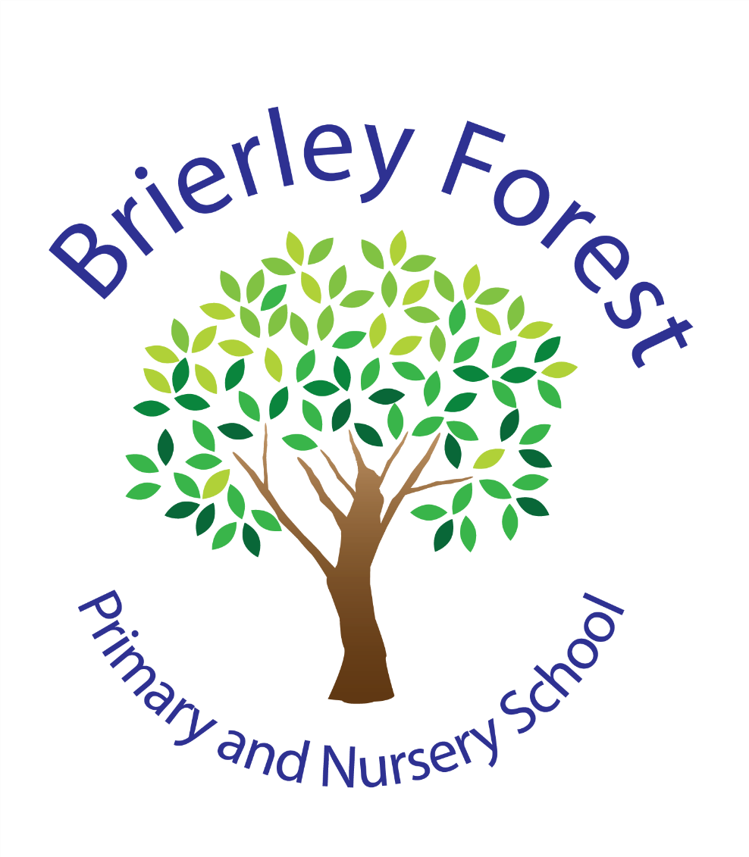

Learn and Grow Together
At BFPNS, we create a caring family of resilient learners, enabling all individuals to thrive in our community.
Belonging, Caring, Resilience, Integrity

Background

At Brierley Forest Primary and Nursery School we aim to provide a positive learning environment for all children, where effective teaching and learning can take place. We believe that effective communication between home and school is essential to supporting children in their learning.

Aims
- To establish more effective communication links with families.
- To enhance the current effective behaviour policy.

Introduction
- ClassDojo is an online tool which offers many useful features including behaviour management, calendars, family and teacher communication as well as class/school newsfeeds. Brierley Forest Primary and Nursery School will use ClassDojo for all of these features.
- ClassDojo is free and works on any iOS/Android/Kindle Fire device or web browser. Families can also read all Class Story posts in their preferred language instantly.
- In order for the system to work efficiently and effectively, this document will highlight the stipulations around use from teachers and families in order to keep ClassDojo as a positive tool.
- These stipulations will be annually reviewed during and after implementation of ClassDojo to reflect the values of the school.
- ClassDojo is compliant with the GDPR and families give permission for the school to process their child's data on the system when they complete the data processing consent form. All information on ClassDojo is private between teachers, families and children. Information is never sold and ClassDojo permanently deletes pupils’ personal information when they stop using ClassDojo. Teachers, families and children can always access and delete their information at any time.

How does Class Dojo work?
- We use the ClassDojo App to communicate securely with families about their children online. The app offers a social media style interface which manages the flow of frequent information from school to home.
- Families are sent an invitation to their email address/phone number which connects them to their child's account - we use ClassDojo from Nursery all the way through to Year 6. Staff will not accept requests from anyone asking to join the community as we cannot be certain of the identity behind the request.
- Pupils will have the opportunity to login to their own area of ClassDojo and change their avatar (monster) as well as view their points and see their class story. Please note, children do not have access to use messaging services through ClassDojo.
- It provides an easy way for you to join the conversation. It is secure and personal to our school and provides information in an easy to use format similar to X (twitter), Instagram and Facebook.
- We will use ClassDojo to keep in touch with you about school events, send reminders and send celebratory messages about learning and community activities.

Class Dojo has a range of different elements which we will be using:
- Dojo points - Children will collect Dojo points for the morning, lunchtime and afternoon sessions from staff when they follow our school expectations.
- School messaging – direct messaging between the families and school/teachers.
- Whole School Story – This will be used to share news and photographs from across the school, informing you about whole school events, sporting results and other whole school information and updates.
- Class Story – This will be used to share general class news, photographs and celebrations, reminders and updates.
- Announcements – Announcements will be used to send important information directly to families such as newsletters/trips/information with deadlines. This can be to specific classes or the whole school.
- Calendars – Staff will use the whole school and class calendars to inform families of events happening in school.

Families and ClassDojo

ClassDojo is only available to families and children registered at the school.

Families are reminded that they should not take images from ClassDojo and post them elsewhere online. What is posted in Dojo stays in Dojo. Breaching this requirement will lead to account suspension.

- Families will receive an invite upon joining our school and it is an expectation that they will have read and follow our school policy.
- Families can use a generated invite code, which they will receive either by text or email, in order to link with their child’s class, either through the use of the smart phone app or website.
- Only families will be given access codes to ClassDojo. It is expected that only parents/guardians will be linked to a child’s account; any additional adults will only be accepted in special circumstances.
- Families can view their child’s dojo points total and story feed. They can like and comment on class posts.
- Families can message teachers; however, a response will only be given during the hours of 8am – 5pm Monday-Friday as the rest of the time teachers are set on ‘quiet time.’
- Families should be aware that teachers will not necessarily respond to messages straight away but will endeavour to do as soon as they are able to during working hours. They may not read the message that you have sent until the end of the day due to their teaching commitments. Please follow existing communication channels such as calling the school office or email if your message is of an urgent nature.
- The following matters should always go through the school office:
- Complaints
- Urgent messages (e.g. collection of children)
- Safeguarding concerns

- Information that is sensitive and private will be sent to the teacher via the private messaging platform and remain confidential.
- If families do not wish for their child’s photographs, digital recordings or work samples to be published on ClassDojo they must indicate so in writing by removing their permissions.
- Families do not have permission share photographs, messages or work samples published on ClassDojo on their personal social media accounts due to a breach of privacy. Families who share private or confidential material or information will be removed from ClassDojo.
- Families will recognise that ClassDojo is a means to share positive understandings of classroom and whole school learning. It should not be used to compare pupils work samples, digital recordings or photographs.
- Families will understand that the number of posts will not be consistent from week to week and will be dependent on events that are happening in school. The number and content of posts may also differ across year groups.

Families must be polite and respectful when messaging teachers or commenting on the class news feed. Any inappropriate comments will be removed.

Families who do not use the messaging system correctly will be given one warning before being taken off ClassDojo.

Teachers and ClassDojo
- Teachers are expected to access their Class Dojo account via the website www.classdojo.com and download the free app onto their school iPad. It should not be downloaded onto personal devices.
- Teachers are expected to send out invitations to the families in their class and regularly encourage families to join up - please remember to add children new to your class if they arrive part way through the year.
- Class Dojo points are to be used as a reward system to promote positive reinforcement and behaviour.
- All members of staff using Class Dojo are asked to set a ‘quiet hours’ on their page, this is when messages will not be read or responded to out of the designated hours. The agreed quiet hours are between 5:00pm and 8:00am Mondays to Friday, and all-day Saturday and Sunday.
- Should teachers receive any messages which they find inappropriate, they should report them to a member of the Senior Leadership Team immediately so that appropriate action can be taken. The teacher will not respond to inappropriate/abusive messages.
- Should a staff member be unable to answer a question via the messaging system, they can ask the family member to phone the school directly.
- Any messages which refer to absences, sickness, progress etc., should be directed to the school office with a brief message.
- Teachers will use the calendar feature to add events that are happening in their class/ whole school with enough time to ensure families have adequate notice.
- Teachers will use the announcement feature to send out important information to families. This will include trips, newsletters, dates for assemblies/classroom events including PE and swimming, any other information which we would expect families to read. This will ensure this goes directly to the family and teachers will be able to see who has read this information.
- School leaders/Admin will also send out whole school announcements.
- Teachers and support staff are encouraged to post updates on their class page- the amount is at your discretion, but the expectation is that teachers post at least twice weekly linked to our school values. In addition, celebrations of work should be shared either individually to families or via the class newsfeed.
- Teachers will only use the first names of the children when posting pictures or messages on ClassDojo (and may, on occasions, use the first initial of a child’s surname also if there is more than one child that shares the same first name within that class).
- Teachers are respectfully reminded to not engage in any conversations about personal matters via the class page or the messaging service.
- Information that is considered sensitive or private will be communicated with families only via the private messaging platform, not through Class Story or School Story.
- All users of Class Dojo are to make themselves fully aware of the children who are in LA care or who do not have permission to have their photographs shared on websites and social media from the school. Teachers will share photos, digital recordings, messages, and work samples only for pupils whose families have given written permission that this information can be shared.
- Teachers cannot share content published on ClassDojo on their personal social media accounts due to a breach of privacy.
- All conversations (private and on the story) will be monitored by the Senior Leadership Team.

Monitoring of the policy

It is the responsibility of all members of staff who use ClassDojo to ensure it is used according to this policy. Monitoring of the policy will be by Senior Leaders who have access to all Class Dojo pages and will be done at regular intervals to ensure the policy is being adhered to.

Brierley Forest Primary and Nursery School teachers, families & guardians who participate in ClassDojo agree to the terms of the Code of Conduct. If these terms are breached, the Headteacher of Brierley Forest will decide on an appropriate course of action.

For more information about ClassDojo please refer to:
https://www.classdojo.com/en-GB/#LearnMore

