The Brierley Way - RSHE

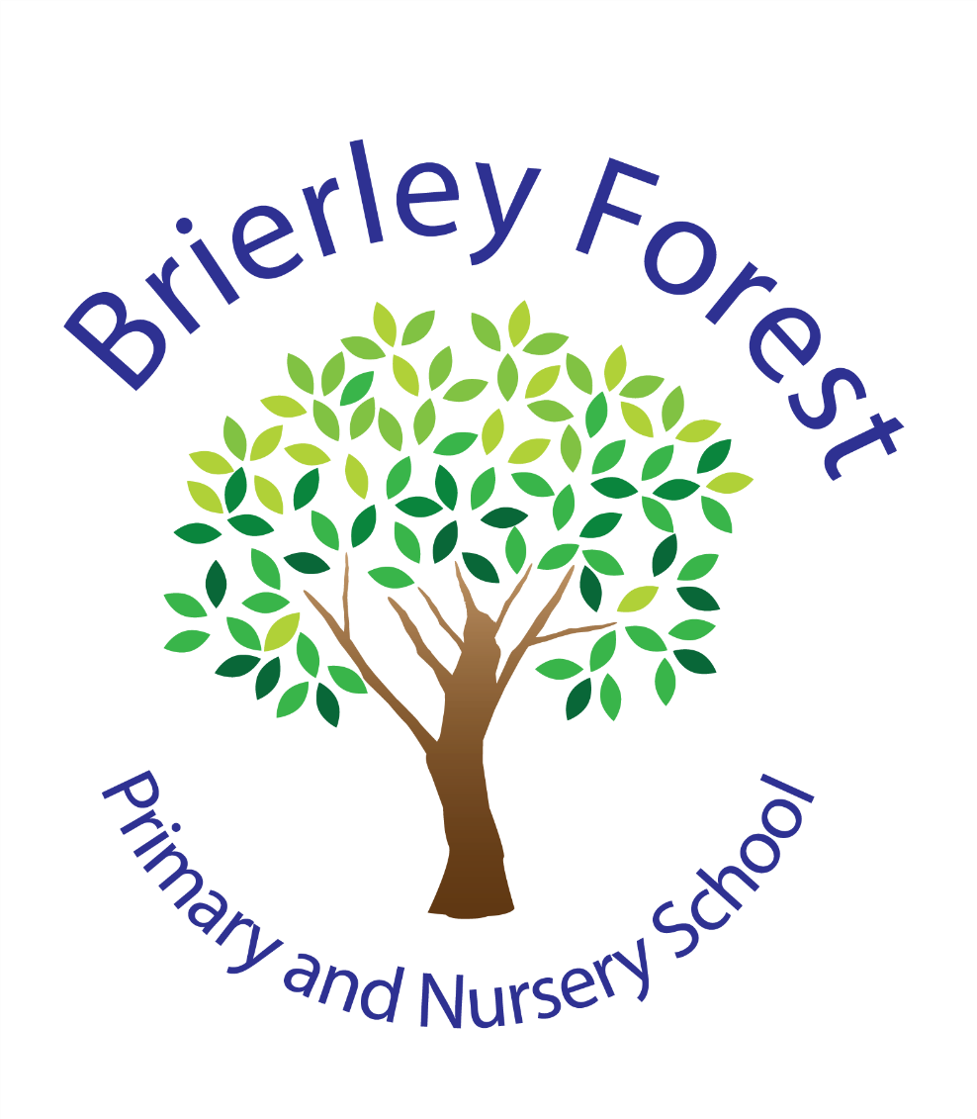

Learn and Grow Together
At BFPNS, we create a caring family of resilient learners, enabling all individuals to thrive in our community.
Belonging, Caring, Resilience, Integrity

Rationale and Ethos
From September 2020, Relationships Education will be compulsory for all pupils receiving primary education and Relationships and Sex Education (RSHE) compulsory for all pupils receiving secondary education. Health Education will also be compulsory in all schools except independent schools. PSHE continues to be compulsory in independent schools.

At Brierley Forest Primary and Nursery School we wholeheartedly support the philosophy of Relationship, Sex and Health Education and believe it is best taught as part of PSHE and citizenship education. The programme seeks to promote the spiritual, moral, cultural, mental and physical development of pupils as well as preparing them for the opportunities, responsibilities and experiences of adult life in a digital age.

Relationships and health education is compulsory in all primary and secondary schools, sex education is currently not compulsory in primary school, however the DfE continues to recommend that all primary schools should have a sex education programme that is tailored to the age and maturity of the pupils.

As part of the Education Act 2002/Academies Act 2010 all schools must provide a balanced and broad-based curriculum which promotes the spiritual, moral, cultural, mental and physical development of pupils at the school and of society, whilst also preparing pupils for the opportunities, responsibilities and experiences of later life.

All schools are required to comply with relevant requirements of the Equality Act 2010 and should pay particular attention to the Public sector equality duty (PSED). Under the provisions of the Equality Act, schools must not unlawfully discriminate against pupils because of their age, sex, race, disability, religion or belief, gender reassignment, pregnancy or maternity, marriage or civil partnership, or sexual orientation (collectively known as the protected characteristics). All schools must ensure that RSHE is accessible for all pupils and should comply with the SEND Code of Practice.

At Brierley Forest Primary and Nursery School children’s wellbeing, happiness and safety are our first priority, and PSHE is the key vehicle through which we share this with children. We regard RSHE as an important, integral component of the whole curriculum; it is central to our approach and at the core of our ethos. This policy and the teaching of RSHE underpins our school expectations of ‘Ready, Respect, Safe’ and we will endeavour to provide our children with a curriculum tailored to their needs.

Whilst as a school we are aware we need to be mindful of and respectful to a wide variety of faith and cultural beliefs, and we will make every attempt to be appropriately sensitive; equally it is essential that young people still have access to the learning they need to stay safe, healthy and understand their rights as individuals.

We acknowledge that all young people deserve the right to honest, open and factual information to help better form their own beliefs and values, free from bias, judgement or subjective personal beliefs of those who teach them.

Policy development process
This policy was formulated in consultation with the whole school community with input from;
- Members of staff – though regular agenda items at staff meetings, consultation documents, surveys
- Governors – discussions at governor’s meetings, training
- Parents/carers – parents will be encouraged to contribute by taking part in written consultations, parent meetings
- Children – pupils contribute to the development of the policy through the school council, circle time discussions etc.
- Other partners – visiting external providers in school; health, police, wider community, faith groups

This will ensure that the RSHE curriculum continues to meet the needs of pupils, staff and parents and that it is in line with current DfE advice and guidance

The Policy is available
- Online at www.brierleyforestprimary.co.uk
- As a paper copy from the school office

Parental rights to withdraw
We are committed to ensuring that the education provided to pupils in RSHE is appropriate to the age of pupils and compliant with the requirements of the Equality Act 2010.

We recognise, in accordance with statutory guidance, that parents have the right to request for their child to be withdrawn from some or all of the sex education delivered as part of the statutory RSHE (other than sex education in the National Curriculum as part of Science), but not from relationships education at primary. Parents wishing to exercise this right must do so in writing to the headteacher, we will make reasonable adjustments and provide suitable work for their child(ren) at this time.

Roles and responsibilities
The Head Teacher has overall responsibility for the policy and its implementation and liaising with the governing body, parents/carers, LA and outside agencies and in identifying a lead teacher who will work closely with colleagues in related curriculum areas in order to complement and not duplicate content.

The Curriculum Lead will take responsibility for;
- Policy development and review involving pupils, staff, governors, parents/carers and relevant partners
- Implementing the policy and monitoring and assessing is effectiveness in practice
- Ensuring evaluation takes place and that this informs policy review
- Assessing and coordinating training and support for staff and parents/carers where appropriate
- Manage all aspects of the RSHE programme developing curriculum materials where appropriate
- Liaise with external agencies to deliver specific elements of the programme
- Monitor and quality assure the programme to ensure continuity and progression within the spiral curriculum
- To ensure that this subject is fully represented at appropriate curriculum and pastoral meetings

The class teachers will take responsibility for:
- Delivering RSHE in a sensitive way
- Modelling positive attitudes to RSHE
- Monitoring progress
- Responding to the needs of individual pupils

Aims and objectives
The aim of RSHE is to help children build healthy friendships and positive relationships in an age appropriate way. The overall objectives of the RSHE curriculum are concerned with raising awareness of attitudes and values, developing personal and social skills and promoting knowledge and understanding. RSHE covers more than biological facts and information. It endeavours to help children develop self-esteem, self-responsibility as well as the acquisition of understanding and attitudes which prepare children to develop caring, stable, healthy relationships. Appreciation of the value of self-respect, dignity, marriage, civil partnership and parental duty should be encouraged in all pupils together with the sensitivity to the needs of others, loyalty and acceptance of responsibility. RSHE will look at aspects of diversity in an inclusive and non-judgemental way.

Staff training
RSHE can be a sensitive issue and teachers may welcome support and training. Provision will be made available for teaching staff to clarify legislation, curriculum requirements and to consider appropriate teaching approaches and materials. The school will support the use of visitors from outside, such as health professionals, police and voluntary sector, and other organisations to provide support and training to staff teaching RSHE.

Curriculum design
The RSHE curriculum at BFPNS will be taught through:
- Weekly dedicated curriculum time/lessons following the KAPOW PSHE scheme of work.
- Links to other areas of the school’s curriculum including but not limited to Project, Science, Physical Education, Religious Education and Computing.
- Assemblies, class assemblies, class discussions and circle time.
- External providers if appropriate.
- Extra sessions with pastoral staff if needed.
- As and when issues arise ensuring time is made within the curriculum to meet the needs of the children.

The programme will be delivered to all students by:
- Dedicated selected staff (normally the Class Teacher/TA) who the children have good relationships with.
- Supported by people with expertise in specific topic areas including where appropriate, the school nurse, police etc.
- The RSHE curriculum is organised in a spiral curriculum which develops themes/topics, considering the age and maturation of the children. This means that topics are revisited in greater detail as students get older.
- Lessons are delivered to mixed-ability teaching groups.
- A variety of teaching and learning styles will be used to ensure effectiveness and differentiation.
- Parents have the right to request withdrawal from all or part of the sex education element, but not from the biological aspects of human growth and reproduction that is part of the National Curriculum science.
- The teacher will discuss and establish ‘ground rules’ at the beginning of every lesson which will enable everybody to discuss openly and honestly without fear and embarrassment or judgement.
- All teachers will endeavour to create a supportive environment for all pupils
- Pupils are regularly informed of who can offer confidential support and where they can services.
- Local data will be used to inform priorities for the school’s RSHE programme – such as schools health profile.
- Across all key stages, students will be supported with developing the following skills;
  - Communication – speaking and listening, including how to manage changing friendships, relationships and emotions
  - Recognising and assessing potential risks
  - Assertiveness
  - Seeking help and support when required
  - Informed decision making
  - Self-respect and empathy for others
  - Recognising and maximising a healthy lifestyle
  - Managing conflict
  - Discussion and group work

Content

Here’s what all pupils should know by the end of primary school. These are the expectations set by the Department for Education.
Families and people who care for me
- That families are important for children growing up because they can give love, security and stability
- The characteristics of healthy family life, commitment to each other, including in times of difficulty, protection and care for children and other family members, the importance of spending time together and sharing each other’s lives
- That other people’s families, either in school or in the wider world, sometimes look different from their family, but that they should respect those differences and know that other children’s families are also characterised by love and care
- That stable, caring relationships, which may be of different types, are at the heart of happy families, and are important for children’s security as they grow up
- That marriage represents a formal and legally recognised commitment of 2 people to each other which is intended to be lifelong
- How to recognise if family relationships are making them feel unhappy or unsafe, and how to seek help or advice from others if needed
Caring friendships
- How important friendships are in making us feel happy and secure, and how people choose and make friends
- The characteristics of friendships, including mutual respect, honesty, trust and trustworthiness, loyalty, kindness, generosity, sharing interests and experiences, and support with problems and difficulties
- That healthy friendships are positive and welcoming towards others, and do not make others feel lonely or excluded
- That most friendships have ups and downs, and that these can often be worked through so that the friendship is repaired or even strengthened, and that resorting to violence is never right
- How to recognise who to trust and who not to trust, how to judge when a friendship is making them feel unhappy or uncomfortable, managing conflict, how to manage these situations and how to seek help or advice from others if needed
Respectful relationships
- The importance of respecting others, even when they’re very different from them (for example, physically, in character, personality or backgrounds), or make different choices or have different preferences or beliefs
- Practical steps they can take in a range of different contexts to improve or support respectful relationships
- The conventions of courtesy and manners
- The importance of self-respect and how this links to their own happiness
- That in school and in wider society they can expect to be treated with respect by others, and that in turn they should show due respect to others, including those in positions of authority
- About different types of bullying (including cyber-bullying), the impact of bullying, responsibilities of bystanders (primarily reporting bullying to an adult) and how to get help
- What a stereotype is, and how stereotypes can be unfair, negative or destructive
- The importance of permission-seeking and giving in relationships with friends, peers and adults
Online relationships
- That people sometimes behave differently online, including by pretending to be someone they’re not
- That the same principles apply to online relationships as to face-to-face relationships, including the importance of respect for others online (even when we’re anonymous)
- The rules and principles for keeping safe online, how to recognise risks, harmful content and contact, and how to report them
- How to critically consider their online friendships and sources of information, including awareness of the risks associated with people they’ve never met
- How information and data is shared and used online
Being safe
- What sorts of boundaries are appropriate in friendships with peers and others (including in a digital context)
- About the concept of privacy and the implications of it for both children and adults (including that it’s not always right to keep secrets if they relate to being safe)
- That each person’s body belongs to them, and the differences between appropriate and inappropriate/unsafe physical and other contact
- How to respond safely and appropriately to adults they may encounter (in all contexts, including online) who they don’t know
- How to recognise and report feelings of being unsafe or feeling bad about any adult
- How to ask for advice or help for themselves or others, and to keep trying until they’re heard
- How to report concerns or abuse, and the vocabulary and confidence they need to do so
- Where to get advice (e.g. family, school, other sources)

Source:
These expectations are set out in the Department for Education’s guidance for schools on relationships education, RSHE and health education.

Implementation through teaching and learning

The implementation of this policy is the responsibility of all teaching staff. In line with Statutory guidance children from Early Years Foundation Stage, Key Stage One and Key Stage Two will learn a range of skills, knowledge, concepts and attitudes through a range of activities.

Early Years Foundation Stage
RSHE is part of PSED (Personal, Social and Emotional Development) and it is a Prime Area in the EYFS curriculum.
The aspects include:
- Self-confidence and self-awareness
- Managing feelings and behaviour
- Making relationships

It is also covered through the Prime Area PD (Physical Development).
This aspect covers:
- Health and self-care

In the Foundation stage our early learning goals involve the children learning about keeping safe and secure developing an understanding of what is right and wrong and why as well as beginning to consider the consequences of their own actions. They also begin to recognise the importance of keeping healthy and those things that can contribute to this.

RSHE is about making connections and is strongly linked to play. RSHE is taught through activities that are part of projects, as well as on an individual basis to develop personal skills. Positive experiences are built through daily opportunities to share and enjoy a range of different activities. Teachers also encourage children to share their feelings daily and learn how to manage their feelings in a safe and nurturing environment.

Key Stage One and Key Stage Two

During KS1 and KS2, learners build upon the skills, attitudes and values, knowledge and understanding that they began to acquire in EYFS and will begin to follow a more structured lesson approach.

As a school we follow the KAPOW Scheme of work for our PSHE teaching which was written to cover the 2020 statutory RSHE guidelines. The scheme is delivered through a range of activities, which encourages the children to form and share their opinions whilst valuing differences. Its aim is to develop children’s understanding of themselves, their emotions and how to interact appropriately with others. It also teaches children how to stay safe in many situations and who to speak to if they are ever worried or concerned.

Managing difficult questions
It is inevitable that controversial issues may occur as part of RSHE, such as divorce, rape abortion, pornography etc. the issue will be addressed with sensitivity and at a level appropriate to the age group and developmental stage and will take in to account any additional SEND, in an objective manner free from personal bias. Consideration will be given to the potential for small group or 1-1 discussion for specific questions to be discussed. Account must be taken of different viewpoints such as different religious beliefs. Discussion should be set within the legal framework and students made aware of the law as it relates to these issues. Students are made aware that some information cannot be held confidential, and should understand that if certain disclosures are made, certain actions will ensue. At the same time students will be offered sensitive and appropriate support.

Implementation through assessment, monitoring, evaluation and review
To ensure the RSHE programme is effective, is meeting the needs of pupils and complies with the RSHE statutory guidance, the following strategies will be used to quality assure the programme of study;
Assessment
- Pupils in KS1/KS2 have a specific PSHE book, where they record their work throughout the year. Their work is marked in line with the school’s feedback policy.
- Termly PSED assessments of children in the EYFS.
- Informal observations of children.
- Feedback from whole class/ individual discussions.
- Data and information from MyConcern will be used to understand the application of learnt skills/knowledge.
- Assessment in RSHE is based upon understanding and learning in RSHE, rather than achievement in other areas of the curriculum such as English and Maths.
Monitoring, Evaluation and Review
  - The subject leader will monitor teaching and learning in RSHE at Brierley Forest, ensuring that the required content is covered.
- Feedback from staff and pupils including representatives from the pupil voice.
- The policy will be reviewed on an annual basis by the subject’s leaders and the headteacher.
- Any changes made to this policy will be communicated to all teaching staff.
- This policy is reviewed annually by the governing body who will monitor the application and outcomes of this policy to ensure it is working effectively

Confidentiality and child protection
It is inevitable that effective RSHE which allows for open discussion to take place may lead to disclosures from pupils. It is essential that those teaching RSHE are completely familiar with the child protection procedures. Pupils disclosures or suspicion of abuse must be followed up with the pupil concerned, that same day and referred to the designated safeguarding lead, and if not present their deputy. They will deal with these disclosures or suspicions in line with the child protection policy.

Links with other policies
The RSHE policy should be read in conjunction with the following policies;
- Safeguarding
- Behaviour
- Anti-bullying
- Online safety
- Sex Education
- SEND
- Inclusion
- Equality and Diversity
- Complaints Procedure

Useful documents
- DfE 2019, Relationships Education, Relationships and Sex Education (RSHE) and Health Education; Statutory guidance for governing bodies, proprietors, head teachers, principals, senior leadership teams, teachers
- SEND Code of Practice
- Relationships Education
- Safeguarding: NSPCC PANTS rule with film.
- Example of model primary curricula from Catholic Education.
- Relationships and Sex Education
- Sexual health and relationships: up to date information on all aspects of sexual and reproductive health available on Sexwise’s website which teachers may find helpful for their knowledge.
- Abuse in relationships: Disrespect NoBody from the Home Office and Government Equalities Office.
- Consent: PSHE Association lesson plans from the PSHE association.
- LGBT inclusivity: Stonewall lesson plans and materials for primary and secondary.
- Resources covering all contexts, including online, and specifically relationships and bullying, alcohol, smoking, stress, body image from Public Health England website with videos made by young people and resources tested with teachers.
- Example model secondary curricula from Catholic education.
- Mental health
- Mental health and emotional wellbeing lesson plans from PSHE Association.
- MindEd educational resources on children and young people’s mental health.
- Online safety
- Education for a Connected World is the UK Council for Internet safety (UKCCIS) framework of digital knowledge and skills for different ages and stages.
- Sexting advice from UKCCIS for schools on preventative education and managing reports of sexting.
- Thinkuknow is the education programme from National Crime Agency (NCA) and Child
- Exploitation Online Programme (CEOP), which protects children both online and offline. The site offers materials for parents, teachers and pupils on a wide range of online safety issues and facts about areas such as digital footprints, recognising fake websites and checking URLs.
- PSHE
- PSHE Association Programme of study for KS1-5
- Drugs and alcohol
- Planning effective drug and alcohol education from Mentor-ADEPIS research and briefing papers with ideas for lessons
- Extremism and radicalisation
- Practical advice and information from Educate Against Hate for teachers, teachers in leadership positions and parents on protecting children from extremism and radicalization.
- Curriculum
- Non-statutory framework for Citizenship KS 1 and 2 (Non-statutory programme of study).
- Schools may wish to draw on the Citizenship programme of study in their planning.
- Data to understand the health and wellbeing needs of the local school-age population
- Public Health England’s Child and Maternal Health Intelligence Network brings together a range of publicly available data, information, reports, tools and resources on child and maternal health into one easily accessible hub.
- It includes school-age health profiles and young people’s health profiles.
- The indicators allow areas to see how they perform against the national average and against other local areas. These tools, accompanied by local health intelligence, will be useful in supporting schools to identify and respond to the particular health and wellbeing needs of their local school-age population.
- There are also Early Years health profiles.

