The Brierley Way - Marking and Feedback

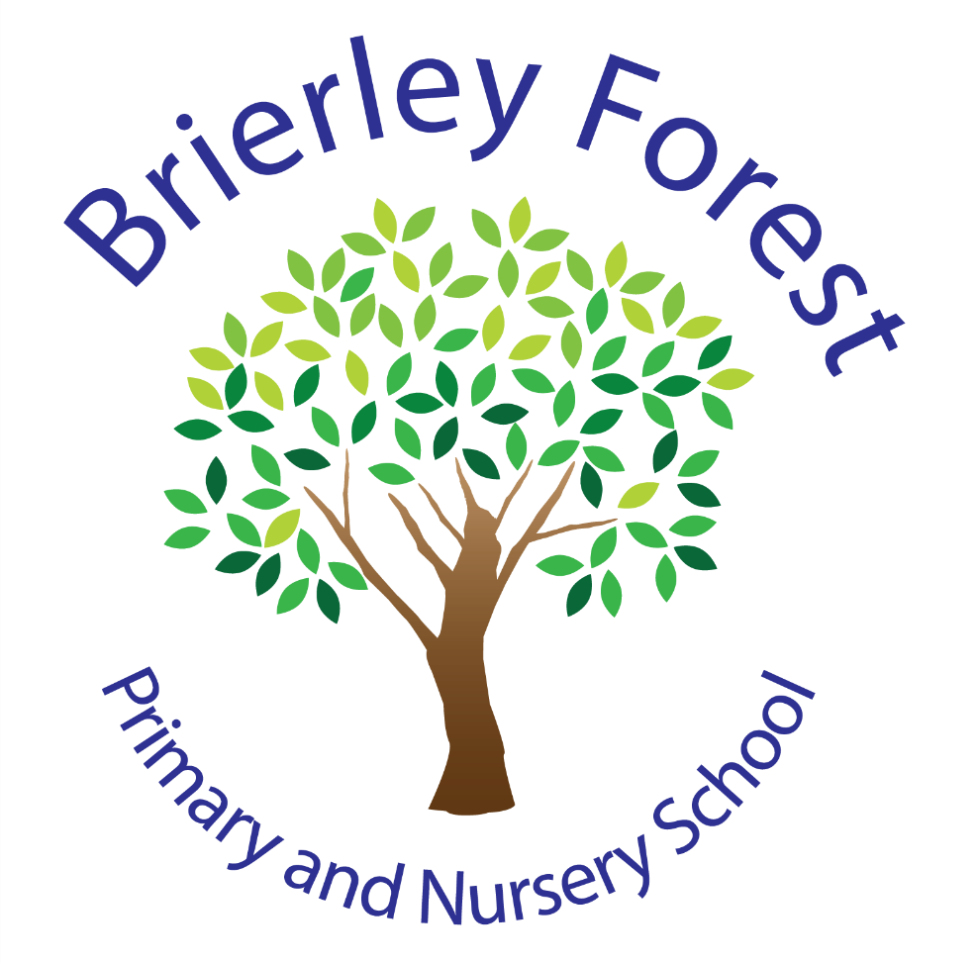

Learn and Grow Together
At BFPNS, we create a caring family of resilient learners, enabling all individuals to thrive in our community.
Belonging, Caring, Resilience, Integrity

What is feedback?

The EEF define feedback as…

“Information given to the learner about the learner’s performance relative to learning goals or outcomes. It should aim to (and be capable of producing) improvement in students’ learning.”

John Hattie (2012) also explains…

“The mistake I made was seeing feedback as something teachers provided to students. I discovered that feedback is most powerful when it is from the student to the teacher. What they know, what they understand, where they make errors, when they have misconceptions, when they are not engaged – then teaching and learning can be synchronized and powerful. Feedback to teachers makes learning visible.”

This document reflects the values, practices and beliefs of the children, staff and the Governing Body at Brierley Forest Primary and Nursery School. Its purpose is to optimise potential, raise standards and ensure that all children are given access to the highest possible standards of teaching and learning.

We ensure feedback:

- Is purposeful, whether it be from an adult or a peer.
- Maximises learning potential.
- Helps children learn how to be the best they can be.
- Informs planning so that it can be adjusted to meet the needs of the children, enabling them to secure learning.
- Facilitates and improves communication between children and teachers/teaching assistants.
In constructing this policy, staff have considered the following factors:

- Why has work been marked? Is it necessary?
- Who is it for?
- Can the child access the feedback given?
- How does it promote learning?
- Has it been effective?
- Have children responded appropriately?
Principles

Feedback is marking. At BFPNS, we believe that feedback to anyone should use a variety of forms. These should include a balance of verbal and written feedback, whole-class, small group and 1:1 feedback, and feedback from different people - adults, peers and self. The type of response used will be influenced by the purpose of the work being produced and every child should receive some form of feedback daily.

Feedback should be positive, constructive and informative about what the child must do to improve the quality of their work. Feedback should always demonstrate that the child’s work is valued.

Written Feedback

Written feedback is completed using red pen so that it stands out from written work. Correct work will be ticked, and incorrect work will be indicated with an ‘X’.

Learning Objectives are highlighted/RAG rated to indicate the child’s success at achieving the objective.
Green = achieved LO independently
Amber = achieved with support/working towards achieving independently
Red = not yet achieved.

Verbal feedback is indicated with a ‘v’ and a word or phrase that encapsulates the feedback i.e. ‘v – adjectives’. Children should be able to articulate how they can improve that particular piece of work.

If a child receives support to complete a piece (or part) of work this is marked with an ‘S’ and person’s initials, near the LO. This includes if they have had support from a peer.

Feedback on work that is recorded digitally follows the same principles as above. However, typed feedback or voice notes may be more appropriate.

Errors in basic skills are pulled out by the teacher, e.g. full stops, capital letters etc regardless of the subject being taught.

The learning objective must form the focus of the feedback in every piece of work – this will often be subject specific i.e. in an RE based lesson the feedback may be asking questions to deepen the child’s thinking.

Methods of feedback

Verbal with written
Through observation, class discussions and pupil interviews, it has been established that verbal feedback is the most effective form of feedback in helping a child to understand where they have succeeded and what they must do to improve.

The quality of the feedback is crucial; using higher order questioning, modelling and exemplification should not be reserved until the completion of a piece of work. Such feedback should be given whilst the work is ongoing to enable the child to immediately experiment with, develop and implement the new information.

Self and peer feedback
These must be explicitly taught, deliberately practiced, reviewed and become an integral part of the teaching and learning process. They must not become the mainstay of feedback that children receive. Teachers should carefully select which pieces of work child led feedback is appropriate for. At BFPNS, we recommend using the work of Austin’s Butterfly with the children to develop understanding of self and peer feedback.

Completed within lessons, self and peer feedback provide children with immediate feedback enabling them to correct work, check methodology, seek advice or support and make improvements while the objective and process are most relevant. This process must be deliberately taught and practiced.

Marking their own work gives children the time to reflect upon their progress towards achieving the learning objective. It also helps to develop resilience and independency. For effective self-review to take place, children need to be taught, and understand the necessary skills involved in giving and receiving effective feedback. Children will follow the same guidelines as staff when giving feedback

Green pens
Where appropriate, children respond to feedback in the lesson by improving their work using a ‘green pen’. There is no expectation that children go back and simply add in (for example) the missing capital letters where the teacher has circled missing punctuation. Children do not learn from doing this and it increases teacher workload.

Green pens are also used to revise writing. Expectations for presentation of work remains the same.

Distance Feedback
Distance feedback is feedback away from the point of teaching. We recognise that too much information for children is often unhelpful as it causes cognitive overload. Giving children too much to focus on at once can be confusing and demoralising for them.

Tips for providing effective distance feedback:

- Only give written feedback if a child can independently read and comprehend what is asked of them. For some children, written feedback may include the use of dual coding. However, symbols need to be familiar to them.
- Written feedback (marking) should show the children where they have made mistakes and provide an example of a WAGOLL, which is their target for the next piece of written learning, denoted by an arrow ( ).
- Children need to be challenged by the feedback and encouraged to see that making mistakes is a way of improving their learning.
- Children should respond to spellings and incorrect maths answers using green pen, which needs to be checked to ensure the practice has been accurate.
- There is a maximum of 3 spellings for KS1 and year 3, and a maximum of 5 for Years 4, 5 and 6. Teachers make a professional judgement about how many times the word needs to be practised and indicates this in the margin next to the spelling.
- Written feedback is not appropriate for the final “polished” piece of writing. Feedback should be seen in the lead up to their final draft, with impact seen in their final, polished piece of writing.
- The target identified at the end of a piece of written work, is transferred by the child to underneath the next days Learning Objective. This is then RAG rated at the end of the lesson.

Responding to non-written work
- The principles of responding positively and constructively to children’s work are equally applicable in practical subjects such as art, design and technology, music and physical education.
- In most cases feedback in these subjects is in the form of a verbal comment, following guidance above.

Teacher’s Feedback Symbols

Symbol | Meaning
RAG Rated Learning Objectives | Red - (pink)- Not met learning objective;  Amber - partially met LO/met LO with support;  Green - achieved Learning objective.
V - adjective | Indicates verbal feedback and the focus of it – serves as a prompt for the child.
x | Wrong answer.
 | Correct answer.
‘G’ | The work was part of a guided group. (This is useful for future reference e.g. work scrutiny, feedback to parents)
‘S’ + staff initials | For use of other Teachers/ TAs that have supported a child and are not the normal Class Teacher. (This is useful for future reference e.g. work scrutiny, feedback to parents)
ST | Supply Teacher  (Check it is still marked correctly)
Splleing | Spelling mistake for the child to correct – if appropriate write the correct spelling for the child.
The moon took the dog for a walk. | Word/phrase/sentence doesn’t make sense.
As the man fell over he put his hands out to break his fall | Punctuation is missing.
He aSked the policeman. | Incorrectly formed/sized letter – this will be modelled in the margin or at the end of the piece of work as appropriate, with an opportunity for the child to practice.
Each sentence starts with a capital letter.  A | Target for following piece of work, with or without a sentence explaining, and may include an example.
A | Capital letters are missing, target for next lesson.
 | Full stops are missing, target for next lesson.
, | Commas are missing, target for next lesson.
Any punctuation/letter in a box  . | “punctuation” is missing or a specific letter formation, target for next lesson.
 | Finger spaces are missing, target for next lesson.

Children’s Feedback Symbols

SA | Self-assessment
PA | Peer assessment

