Blended and Remote Learning Policy
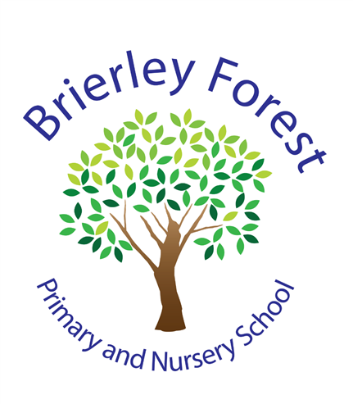

At BFPNS, we create a caring family of resilient learners, enabling all individuals to thrive in our community.

Specific Aims

- To identify differences between a blended and remote learning approach.
- To outline our approach for children who are unable to attend school for a specific reason/period of time (where they are ordinarily well and are able to do so).
- To outline our approach for children who are on a part time timetable.
- To outline our expectations for staff who will not be attending school for a reason such as self-isolation, but that are otherwise fit and healthy and able to continue teaching and planning for children.

Who is the policy applicable to?

This policy is applicable for the children, families and staff of Brierley Forest Primary and Nursery School.

Every child of school age is expected to attend school. There are circumstances where school may have to close, or a child is unable to attend school and during these periods of time, it is expected that children will continue their learning through a blended and remote learning approach. Examples of such times might be: a pandemic (such as COVID-19), closure of the school due to snow, a flood or if an individual needs to self-isolate.

What are the differences between blended and remote learning?

Blended Learning combines face-to-face learning and learning via digital means, and is our standard approach in our day-to-day teaching.

Remote learning is when children complete work away from school and away from face-to-face contact (whether in person or via technology). A member of the teaching staff may set work to be completed digitally, paper form or as a physical research task.

Remote learning for children

We will provide links to appropriate remote learning for children who are not able to attend school so that no-one need fall behind. Remote learning should equate to approximately 3 hours per day for Key Stage 1 and 4 hours per day for Key Stage 2.

The governors and senior leadership team at Brierley Forest Primary and Nursery School are fully aware of exceptional times and the importance that all children should be able to access learning. We realise that the circumstances that cause our school to close will affect families in a number of ways. In our planning and expectations, we are aware of the need for flexibility from all sides:
- Families may be trying to work from home so access to technology as a family may be limited;
- Families may have two or more children trying to access technology and need to prioritise the needs of young people studying towards GCSE/A Level accreditation;
- Teachers may be trying to manage their home situation and the learning of their own children;
- Systems may not always function as they should.

What is blended learning?

The term ‘blended learning’ is used in education to describe a teaching style that allows students to learn using a combination of technology and online educational exercises or materials to assist in the classroom, whilst having a 'traditional' hands-on and in-person lesson. For this to be successful, teachers must be integrating the use of online platforms into their day-to-day teaching where possible, building children’s confidence in using them independently. Such online platforms may include, but is not limited to:
- Teams lessons and completion of tasks via Showbie.
- TTRS
- Spelling Shed

A successful blended learning approach will support children in making a positive transition from more traditional learning in the classroom, to learning through technology.

When in school, children are explicitly taught the skills required to enable them to access blended and remote learning from home.

Teacher expectations

Using a blended learning approach, teachers will plan lessons that are relevant to the curriculum focus for that year group and endeavour to supply resources to support tasks for home learners - these will be the same resources that are being used in class as far as possible. A ‘live’ teaching approach may be adopted by the teacher so that all children are able to come together as a class in the event of a school closure.

Child participation in real-time
Where possible children unable to attend school will access their Microsoft Teams account and remotely participate in lessons alongside their peers. Children will be able to view the lesson content but not the teacher and/or the rest of the class.

Through real-time Teams participation, children will be able to:
- Have direct access to lesson input from teachers
- Participate in class discussions
- Complete work using Microsoft software, including Word, Excel, Sway and PowerPoint
- Access any additional worksheets, websites and other online resources necessary
- Clarify any instructions given by their teacher through the chat function

Work completed by children during these sessions, will be recorded electronically and saved onto their class Teams site for teachers to review. Live feedback in line with the school’s Feedback Policy, will also be achieved by using the share screen option and live modelling/amending of work.

Participation at any time
Where real-time participation in sessions is not possible for children, live lessons will be recorded and uploaded for children to access at a later date should they need or want to. Teachers will share website links needed to access home learning resources along with clear information about the learning for that week through a post to the class Teams site.

This will include:
- A daily English lesson, to include reading and phonics where appropriate
- A daily Maths lesson
- A weekly science lesson
- A weekly RE lesson
- Weekly project lessons
- Weekly PE lesson ideas
- A weekly PHSE lesson

All resources used, including website links and worksheets, should, where possible, be shared with home learners via Teams. Staff will add these resources to their class Teams site.

Supporting access

- Teachers will respond promptly, within reason, to requests for support from families at home. This should be done via the office email, a phone call, Class Dojo or the child’s Teams if needing to look at work and (for example) share screens for clarity.
- Should a staff member require support with the use of technology, it is their responsibility to seek this support in school and Senior Leaders will ensure that support is given promptly.

Family (child/parent/guardian) role
- Where possible, it is beneficial for young people to maintain a regular and familiar routine. Brierley Forest Primary and Nursery School would recommend that each ‘school day’ maintains structure. A suggested timetable will be put on the relevant class Teams site and the class web page as a guide.
- Where school is closed, blended and/or remote learning will begin as near to the closure time as possible, e.g if in a morning, blended/remote learning will begin in the afternoon of the same day.
- Should anything be unclear in the work that is set, families can communicate with class teachers via Dojo or Showbie directly to the relevant member of staff.
- We would encourage families to support their children’s work, by viewing the work set together, and then making appropriate plans to complete the work – including providing adequate space and time. This can include finding an appropriate place to work and, to the best of their ability, supporting children with work encouraging them to work with good levels of concentration.
- Every effort will be made by staff to ensure that work is set promptly on appropriate platforms, but school cannot guarantee that the chosen platforms will work on all devices. Should accessing work be an issue, families should contact school promptly and alternative solutions will be agreed. These will be discussed on case-to-case basis.

