The Brierley Way - Assessment

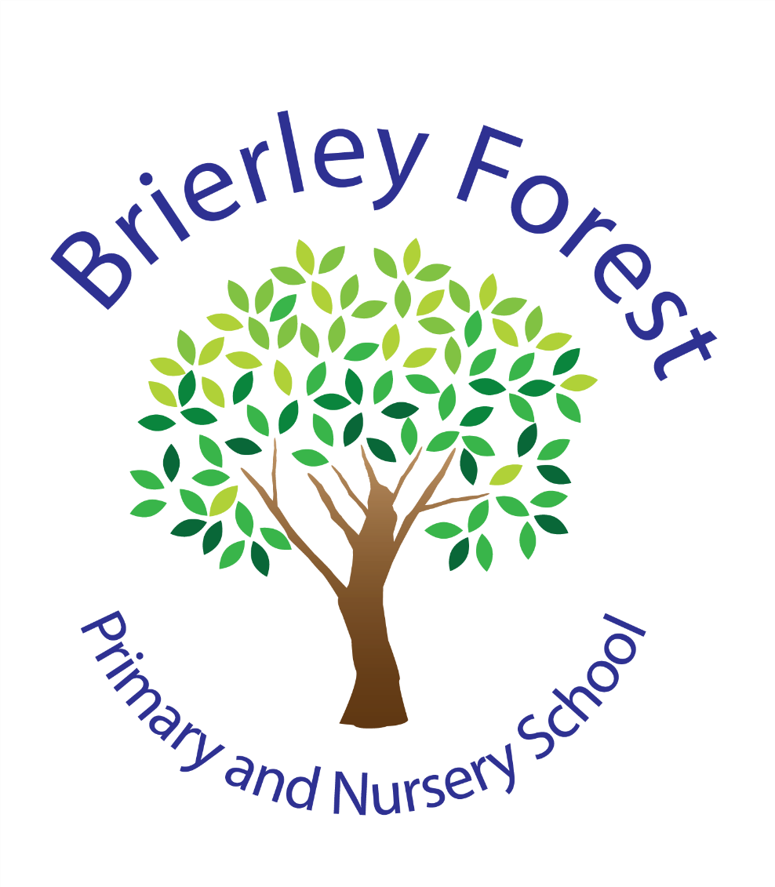
Learn and Grow Together
At BFPNS, we create a caring family of resilient learners, enabling all individuals to thrive in our community.

Belonging, Caring, Resilience, Integrity
Our vision for assessment
At Brierley Forest Primary and Nursery School, we believe that all forms of assessment should be used to improve teaching and learning.
We believe that the best form of assessment results from ongoing dialogue and interactions with children. Daily interactions are what provide the soundest judgements of pupil progress and are what should inform planning and teaching. We recognise that progress in learning is not linear and therefore children should not be judged solely on the basis of a test.
Where data is gathered, it should also be used as a means to support teacher assessment judgements.
Aims
This policy aims to:
- Provide clear guidelines on our approach to formative and summative assessment
- Establish a consistent and coherent approach to recording summative assessment outcomes and reporting to parents
- Clearly set out how and when assessment practice will be monitored and evaluated

Intent:
At BFPNS, we see assessment as an integral part of teaching and learning; it is the means by which the progress of children is monitored and accelerated.
We categorise into three forms:
Assessment of Learning (AoL) – This usually takes place as a summative test at the end of a unit/ period of time. The process should be clear for children to demonstrate their competence and skill.
Assessment for Learning (AfL) – Teaching staff will do this at the point of teaching using a variety of strategies. AfL assesses how children are progressing and often occurs more than once during a lesson. Feedback to the child is immediate and should identify what they can do, address misconceptions and give advice on how to improve. AfL allows teachers to adjust their planning to secure learning for pupils.
Assessment as Learning – Children will learn about themselves as learners. They will become aware about how they learn, develop confidence and reflective skills to assess and take responsibility for their own learning.
Effective assessment enables:
- School leaders to monitor the performance of pupil cohorts, identify where interventions may be required, and work with teachers to ensure children are supported to achieve sufficient progress and attainment.
- Teachers to evaluate learning during a lesson and at the end of a unit or period of time. They will reflect on the impact of their own teaching and adjust lessons accordingly.
- Children to understand how well they have learned and understood a topic or course of work taught. They will be able to reflect on their own learning and receive feedback as to how they can improve.
- Parents to stay informed about the achievement, progress and wider outcomes of their child across a period of time.
We work hard to ensure that assessment is fair, inclusive, appropriate and meaningful.
Implementation:
Nationally standardised summative assessments include:
- Early Years Foundation Stage (EYFS) profile at the end of reception.
- Phonics screening check in year 1, with a ‘mop up’ in year 2.
- Statutory Assessment Tests (SATs) and teacher assessments at the end of Key Stage 2 (year 6)
- Multiplication Check in year 4

Formative assessments take place daily, in all lessons. Teachers will assess children and further support or challenge to secure and deepen knowledge, skills and understanding.

Collecting and using data
EYFS:
On entry to nursery/reception, children are assessed within the first few weeks of starting. Reception children are baseline assessed and then ongoing formative assessments are made throughout the year against the prime and specific areas of learning. These determine whether a child is on track or not on track to achieve the expected level of development that is required at the end of the reception year for each of the 17 areas in the Early Years Foundation Stage Profile.
Towards the end of each academic year, teachers make their final judgements and complete the Early Years Foundation Stage Profile. They report as follows for the 17 areas of learning:
- Expected – the child has met the expected level of development
- Emerging – not yet reached the expected level of development

From the areas of learning, an overall judgement will be made as to whether the children have achieved the Early Learning Goal (ELG) or not.

KS1 and KS2
Information through assessment for learning is collected on an ongoing basis by the teacher. At the end of each term, teachers are required to provide an assessment judgement based on how each child is performing against the national curriculum objectives. They will collect evidence from work completed independently by the child in class, discussions with the child to check that knowledge is retained, and summative assessments.
Formative and summative assessment data is recorded onto the school’s assessment tracking system (Insight). This enables school leaders and teachers to monitor progress over time and attainment at certain points in the year, as well as measure the impact of targeted interventions.
Summative assessments include:
Who | When | What | Data
Years R, 1, 2  Targeted children in years 3 and 4. | Six-weekly checks 1:1 with the Phonics Lead. | Read Write Inc. Phonics Check. | Recorded on Insight and Read Write Inc portal.
Year 1 and targeted pupils in year 2 | Second week in June | Phonics Screening Check. | Marked, recorded on Insight and sent to the DfE.
Years 1, 2, 3, 4, 5 | Autumn,  Spring,  Summer terms  (see calendar for dates) | HeadStart Assessments in reading and GPS.  Ark Maths Mastery Assessments.  Cold writing assessment (teacher assessed). | Raw data collected on Smartgrade and tracked on Insight.  Question and Topic Level Analyses are completed by Smartgrade.
Year 4 | First two weeks in June | Multiplication Tables Check through TTRS and the DfE. | Data sent to the DfE.
Year 6 | Autumn terms 1 and 2.  Spring terms 1 and 2.  Summer term 1 – May. | SATs – past papers (autumn and spring terms).  May SATs.  Cold writing assessment (teacher assessed). | Recorded on Insight and SmartGrade.
Year 6 |  |  | May 2027 SATs: externally marked – results returned to school for checking – early July.  Results recorded onto Insight.

Absent children should sit the tests when they return to school (with the exception Y6s who are absent throughout the summer term SATs window).
New children to BFPNS should sit the previous term’s assessment papers so that we have a baseline. This should be recorded onto Insight for that specific term.
Science and foundation subjects: Each term, teachers will make a judgement on the children’s abilities to meet the DfE’s objectives for each subject. These judgements are recorded as have not met (HNM) or have met (HM) on Insight. This terminology aligns with that used to report science judgements at the end of KS2.

Wellbeing and Involvement.

The Leuven Scale is a form of assessment developed by Ferre Leavers and his team at Leuven University in Belgium. It is a five-point scale that allows childcare practitioners to measure children's 'emotional well-being' and 'involvement' – two vital components of learning, development and progress in children.

According to Leavers, children in a high state of ‘well-being’ are like ‘fish in water’. They are comfortable in their environment, confident and eager to experiment and explore. Whereas, children with low levels of well-being often appear frightened, anxious and dependent, making it hard for them to learn in a sustained way and explore their potential.

Similarly, high levels of ‘involvement’ – characterised by curiosity, fascination, deep satisfaction and a genuine interest in what they are doing – is an indicator of ‘deeper-level’, meaningful learning.

Information is recorded on Insight.

For more information on The Leuven Scale, click here.

Performance Indicators:

Teacher assessment should be recorded using the following indicators:
- Below – an attainment measure for children who are significantly behind their year group expectations (known as pre-key stage standards).
- Working towards the expected standard (WTS) – an attainment measure that indicates a child is working towards the understanding of the curriculum objectives for their year group.
- Expected Standard (EXS) – an attainment measure that indicates a child can demonstrate the knowledge and understanding of the curriculum objectives for their year group.
- Greater Depth Standard (GDS) – an attainment measure that indicates a child can apply knowledge of the curriculum, including reasoning, using subject-specific vocabulary and making links and connections between different areas of learning.

Children should not be assessed against the curriculum for higher year groups.
Assessment data will be shared as part of the transition period for when children move on to their next class or new school. This enables their new teacher to assign appropriate work whilst they formatively assess children at the beginning of the year.
Impact:
Nationally Standardised Assessments
Nationally standardised assessments enable:
- The Government to make comparisons between pupils and hold schools to account.
- School leaders to monitor the performance of pupil cohorts, identify where interventions may be required, and work with teachers to ensure children are supported to achieve sufficient progress and attainment.
- Teachers to understand national expectations and assess their own performance in the broader national context.
- Children and parents to understand how children are performing in comparison to children nationally.
- Secondary schools (for KS2 pupils) to have a baseline of children’s achievement in primary school as they enter year 7.

Reporting to parents
At BFPNS, we value the importance of ensuring parents are kept up to date with their child’s progress and attainment. Information regarding these are communicated to families at key points during the academic year, usually in the form of pupil progress meetings (parents’ evenings) and written reports during the summer term.
Teachers will identify a child’s performance indicator, along with strengths and areas for development. Suggestions as to how a child can achieve a given target will also be given.
Inclusion
The principles of this assessment policy apply to all children, including those with special educational needs or disabilities and where English is an additional language.
Assessment will be used diagnostically to contribute to the early and accurate identification of children’ special educational needs and any requirements for support and intervention.
We will use meaningful ways of measuring all aspects of progress, including communication, social skills, physical development, resilience and independence. We will have the same high expectations of all children. However, this should account for the amount of effort the pupil puts in as well as the outcomes achieved.
For children working below the national expected level of attainment, our assessment arrangements will consider progress relative to pupil starting points, and take this into account alongside the nature of children’ learning difficulties.

Training
- Governors attend training on assessment. The Assessment Lead shows them the key parts of the tracking system that enables them to access anonymised data for questioning, along with the school’s data headlines at key points in the year. Data headlines are also shared with governors on a termly basis through the Headteacher’s Report.
- School Leaders receive training on the school’s assessment tracking systems. The Assessment Lead attends the Transform Trust’s network meetings, and is able to feedback information to staff. The Assessment Lead trains teaching staff and governors, and keeps all staff up to date with important information communicated from the Department for Education. Senior Leaders also train staff on best ways to communicate assessment information to parents at parents’ evenings and on written reports.
- Teachers are trained on different forms of assessment, with suggested strategies to use to effectively assess learners. They are encouraged to share good practice and resources. Training and updates on the school’s assessment tracking systems are communicated regularly.
- An assessment protocol supports teachers in effectively using assessment strategies, which includes how to administer assessments and utilise the data gathered.
- School leaders and teachers can ask for advice through the assessment tracking system’s discussion forum and by contacting the support team.
- Children are taught how to effectively self-assess to develop reflective and competence skills to drive their own learning.

Roles and responsibilities
Governors and Trust Directors
Governors are responsible for:
- Being familiar with statutory assessment systems as well as how the school’s own system of non-statutory assessment that captures the attainment and progress of all children. The school’s tracking system (Insight) is anonymised so that Governors do not see names, only data.
- Holding school leaders to account for improving pupil and staff performance by rigorously analysing assessment data
School Leaders
School Leaders are responsible for:
- Ensuring that the policy is adhered to.
- Monitoring standards in core and foundation subjects.
- Analysing pupil progress and attainment, including individual children and specific groups.
- Prioritising key actions to address underachievement.
- Reporting to governors on all key aspects of pupil progress and attainment, including current standards and trends over previous years.
Teachers
Teachers are responsible for following the assessment procedures outlined in this policy. Each term, teachers report pupil progress and attainment to school leaders, who challenge practice to ensure that children receive accurate assessment judgements and know how to improve their work.

Monitoring
All teaching staff are expected to read and follow this policy. The Assessment Lead is responsible for ensuring that the policy is followed.
The Assessment Lead and other school leaders will monitor the effectiveness of assessment practices across the school, through:
- Lesson monitoring, including lesson visits, work scrutinies and pupil interviews.
- Class and phase data reports.
- Appraisal review.
- Learning Plan reviews.

Links with other policies
This assessment policy is linked to:
- Curriculum policies
- Early Years Foundation Stage policy and procedures
- SEND policy
- TT Assessment Policy and timetable

