The Brierley Way –
Anti-Bullying

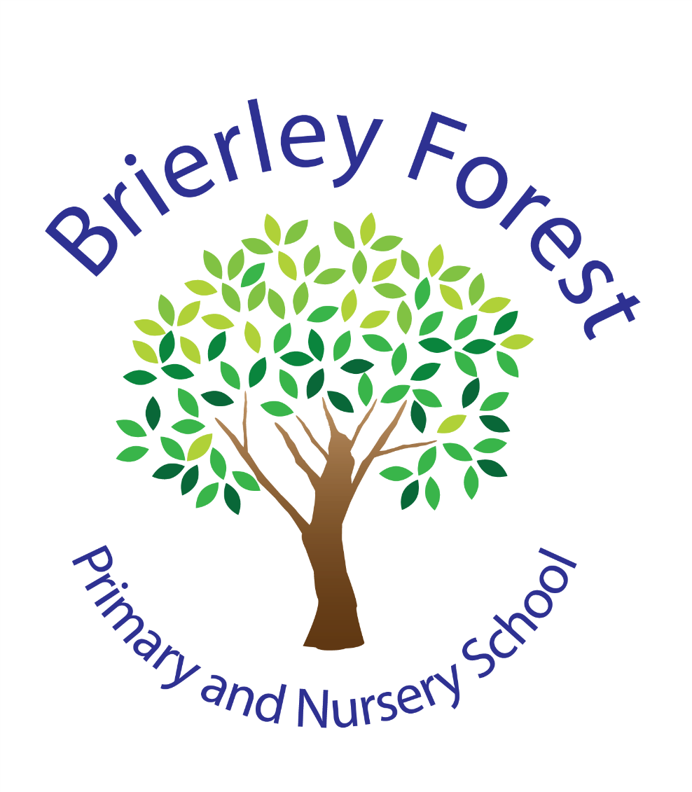
Learn and Grow Together
At BFPNS, we create a caring family of resilient learners, enabling all individuals to thrive in our community.
Belonging, Caring, Resilience, Integrity

Introduction and School Values
At Brierley Forest Primary and Nursery School, we are committed to ensuring that every child feels safe, valued, respected and included.
Our vision is to create a caring family of resilient learners, enabling all individuals to thrive in our community. Our values of Belonging, Caring, Resilience and Integrity underpin everything we do and guide how we treat one another.
We believe that everyone has the right to learn and work in an environment free from bullying, discrimination and harassment. We take all concerns seriously and will work swiftly to prevent, identify and respond to bullying.
We are committed to promoting positive relationships, celebrating diversity and fostering a culture where differences are respected and everyone feels they belong.

What is Bullying?
At Brierley Forest Primary and Nursery School, we use the child-friendly definition:
STOP - Several Times On Purpose
Bullying is behaviour that is:
- Deliberately intended to hurt, upset, intimidate or harm another person.
- Repeated over time.
- Difficult for the person experiencing it to stop.
- Often involves an imbalance of power.
Bullying can take place face-to-face or online.
Not all friendship difficulties, disagreements or one-off incidents are bullying. Children will sometimes fall out, argue or make poor choices. These situations will be taken seriously and addressed appropriately through our Behaviour Policy, but they may not meet the definition of bullying.
School staff carefully consider the nature, frequency, intent and impact of incidents when determining whether bullying has occurred.

Our Inclusive Approach
We celebrate diversity and are committed to creating a culture where everyone feels welcome, respected and valued.
We recognise that some children may be more vulnerable to bullying, including:
- Children with SEND.
- Children with disabilities.
- Children with communication needs.
- Children with social, emotional or mental health needs.
- Children from minority ethnic or faith groups.
- Looked After Children.
- Young carers.
We are committed to removing barriers, promoting equality and ensuring that all children can participate fully in school life.
Any behaviour motivated by prejudice, discrimination or hostility towards an individual's identity or protected characteristics will be taken seriously and addressed promptly.

Types of Bullying
Bullying can take many forms.
Physical Bullying | Verbal Bullying | Emotional or Social Bullying | Online or Cyberbullying | Prejudice-Related Bullying
Examples include:  Hitting  Kicking  Pushing  Damaging property  Threatening physical harm | Examples include:  Name-calling  Insults  Threats  Offensive comments  Deliberate teasing | Examples include:  Spreading rumours  Excluding others  Intimidation  Embarrassing someone publicly  Manipulating friendships | Examples include:  Sending hurtful messages  Sharing inappropriate images or information  Creating fake accounts  Excluding others from online groups  Online harassment through social media, games or messaging services | Bullying may be linked to:  Disability  Race or ethnicity  Religion or belief  Sex  Gender identity  Sexual orientation  Family circumstances

Prejudice Related Bullying
Under the Equalities Act 2010 it is against the law to discriminate against anyone because of:
  - age
  - gender reassignment
  - being married or in a civil partnership
  - being pregnant or having a child
  - disability
  - race including colour, nationality, ethnic or national origin including Gypsy, Roma, Travellers
  - religion, belief or lack of religion/belief
  - sex /gender
  - sexual orientation
These are called ‘protected characteristics’.
As part of the requirement on schools to promote fundamental British values, schools must proactively challenge derogatory and discriminatory language and behaviour including that which is racist, homophobic, biphobia, transphobic and disablist in nature. We will record these types of bullying, even that which represents a one-off incident, and report them to the Trust for monitoring purposes.

Reporting Concerns
We encourage everyone to speak up if they are worried about bullying.
Children should:
- Tell a trusted adult.
- Speak to their class teacher.
- Speak to a member of the safeguarding team.
- Tell their parent or carer.

Parents and Carers: Parents should contact their child's class teacher in the first instance if they have concerns about bullying.

Staff: All staff take reports seriously and follow the school's reporting and safeguarding procedures. All concerns will be listened to, taken seriously and investigated appropriately.

How We Respond
When bullying is reported, we will:
- Implement a feelings chart to monitor and analyse any patterns of incidents for a time period agreed with the alleged victim and parents.
- respond using a range of strategies appropriate to the situation, such as specific PSHE/SEAL lessons, circle of friends or adults, individual work with the victim and any others involved, referral to outside agencies if appropriate
- arrange follow up sessions/discussions as a way of keeping in touch with the person who reported the situation, parents/carers and other parties involved
- Support will be given for the victim and the bully. In the case of incidents of bullying reported by the children, this might be through the use of a one off or more regular small group activities with a designated adult
- investigate initially in line with the school’s Behaviour policy (Behaviour – The BFPNS Way) and school consequences and rewards system. If the bullying persists, then the head teacher will be involved who will then decide on the appropriate actions to be taken
- liaise with the wider community in the case of incidents of Cyberbullying or hate crime
- When appropriate, involve other agencies who may be able to support
- Liaise with the DSL if there are any safeguarding issues to consider- who may refer on to the MASH
- Refer to the Nottinghamshire County Council Pathways to Provision and complete an EHAF if appropriate

Preventing Bullying
Creating a culture where bullying is less likely to occur is a key priority.
We prevent bullying through:
- The Brierley Way Behaviour Curriculum.
- PSHE and RSHE lessons.
- Online safety education.
- Assemblies and themed events.
- Anti-Bullying Week.
- Safer Internet Day.
- Classroom discussions.
- Pupil voice opportunities.
- Staff training.
- Positive partnerships with families.
Across the school, children are taught:
- Kindness and respect.
- Empathy and understanding.
- How to celebrate differences.
- How to resolve conflicts appropriately.
- How to keep themselves and others safe online.
- How to seek help when they need it.
Our school values of Belonging, Caring, Resilience and Integrity help us create a community where everyone feels safe and included.

Recording, Monitoring and Review
Bullying incidents are recorded and monitored by school leaders. Information is reviewed regularly to:
- Identify patterns or trends.
- Monitor vulnerable groups.
- Evaluate the effectiveness of interventions.
- Inform future prevention work.
- Support individual pupils.
Parents will be kept informed throughout the process where appropriate.
This policy is reviewed annually to ensure it continues to reflect current guidance and the needs of our school community.

Roles and Responsibilities

The Headteacher - The Headteacher has overall responsibility for the implementation and monitoring of this policy.

Staff - All staff are responsible for promoting positive relationships, challenging bullying behaviour, reporting concerns and supporting children effectively.

Pupils - Pupils are expected to treat others with kindness and respect, report bullying if they experience or witness it and support a positive school culture.

Parents and Carers: Parents are encouraged to discuss concerns with school promptly, support the school's approach to resolving concerns and work in partnership with staff.

Linked Policies
This policy should be read alongside:
- Behaviour Policy
- Safeguarding and Child Protection Policy
- Online Safety Policy
- SEND Policy
- Inclusion Policy
- Equality Information and Objectives
- Complaints Policy

Review Information
Policy Name: The Brierley Way Anti-Bullying Policy
Date Reviewed: September 2026
Review Date: September 2027
Approved By: Governing Body

