The Brierley Way - Behaviour
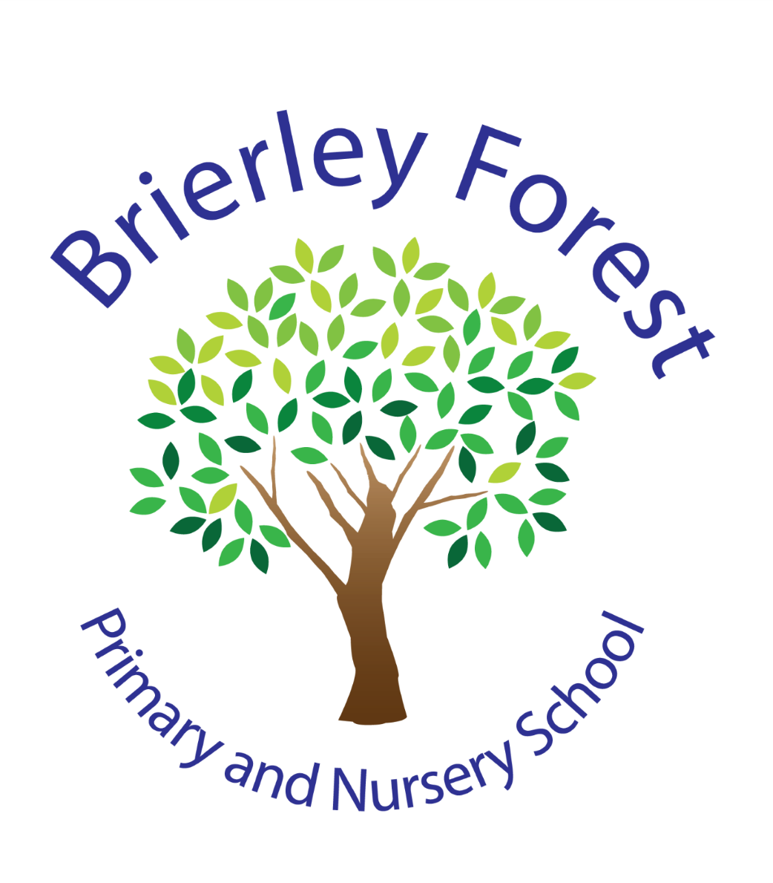
Brierley Forest Primary and Nursery School
Behaviour Policy
2026-27

Introduction

At Brierley Forest Primary and Nursery School, we create a caring family of resilient learners, enabling all individuals to thrive in our community. Our core values of Belonging, Caring, Resilience, Integrity are at the heart of everything we do and underpin our approach to behaviour.
We believe that all children have the right to learn in a safe, supportive and inclusive environment. We are committed to developing positive relationships, teaching children how to regulate their emotions and behaviours, and helping them become responsible members of our school community.
Our behaviour policy guides adults to teach self-discipline, self-regulation and responsibility rather than simple compliance. We recognise that behaviour is a form of communication and seek to understand the reasons behind behaviour while maintaining high expectations for all pupils.
We work in partnership with families to ensure a consistent approach and believe that positive relationships between children, staff and parents are fundamental to success.
School Vision
At BFPNS, we create a caring family of resilient learners, enabling all individuals to thrive in our community.

Inclusive Approach to Behaviour
At Brierley Forest Primary and Nursery School, we recognise that some children may require additional support to achieve our behaviour expectations.
Children's behaviour may be influenced by a range of factors including:
- Special Educational Needs and Disabilities (SEND);
- Speech, language and communication needs;
- Sensory processing differences;
- Social, emotional and mental health needs;
- Attachment needs or trauma experiences;
- Medical conditions;
- Significant life events or changes.
We are committed to making reasonable adjustments where appropriate to help children succeed. We ensure pupil voice is at the heart of any adjustments made. These adjustments may include:
- adapted behaviour targets;
- visual supports;
- personalised reward systems;
- sensory regulation strategies;
- movement breaks;
- adult mentoring;
- individual behaviour support plans;
- risk assessments;
- support from external agencies.
Our aim is to understand behaviour, identify barriers and provide support whilst maintaining high expectations for all children.
EXPECTATIONS | What does this look like? | Why is it important?
READY | - We are in the right place at the right time.  - Attendance at school meets our school target of 96% or more.  - We have the right equipment for our learning (eg. correct uniform / PE kit/ stationary pack).  - We will use our eyes and ears to attend to the speaker.  - We engage with all learning tasks set for us. | To make the most of the opportunities we have at school.
SAFE | - We use and store equipment appropriately (eg. stationary, PE equipment).  - Our behaviour is appropriate to the environment we are in. (eg. walk on the left in the corridor, active areas for football/basketball, quiet areas for chatting with friends).  - We sit on the carpet and our chairs safely. | To keep ourselves and others in our school safe.
RESPECTFUL | - We make everyone feel welcome (eg. Use good manners, say good morning/afternoon, hold doors open).  - We use quiet voices inside and speak kindly to each other.  - We show respect for our school and classroom environment by keeping it tidy. | To help us to grow into good citizens who contribute well to the community.
School Expectations

Recognition and Rewards
Class Dojo points are awarded for meeting our school expectations for each session during the day. One will be awarded for a morning session, one for lunchtime behaviour and one will be awarded for an afternoon session. At the end of each half term, children who achieve 95% of the Class Dojo points on offer will be able to attend Golden Afternoon with their class.
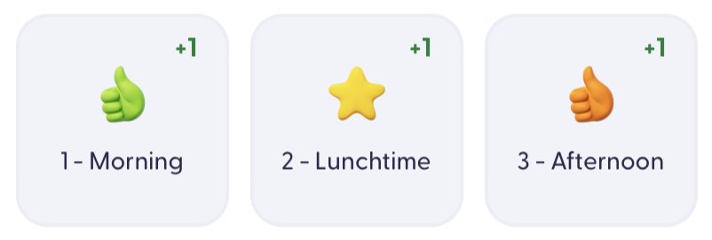
We recognise and reward children who demonstrate our expected behaviour standards. Although there are tiered awards, our staff believe that a quiet word of personal praise can be as effective as a larger, more public rewards. The use of praise in developing a positive atmosphere in the classroom cannot be underestimated. It is the key to developing positive relationships including with those children who are hardest to reach.
- Positive message home via Class Dojo, phone call or in person;
- Games Afternoon each half term for meeting expectations;
- Specific award in recognition of children who demonstrate our school values;
- Curriculum specific awards for outstanding effort (Learning with Parents, Times Table Rock Stars etc)
Consequences
Engagement with learning is always the primary aim. For the vast majority of children, a gentle reminder or nudge in the right direction is all that is needed. A calm and consistent approach is essential; the BFPNS Behaviour Pathway is designed to support both staff and children in understanding the graduated response to poor behaviour. In between each stage, we allow an appropriate amount of time for a child to reset their behaviour.
1 | 2 | 3 | 4
REMINDER | WARNING | CONSEQUENCE | REFLECT & RESET
A reminder of expectations Ready, Respectful, Safe delivered privately wherever possible. | A clear verbal caution delivered privately wherever possible. | A clear explanation of how their behaviour impacted others in our school community and what the consequence will be. | A chance to speak to the learner privately.  Reflect and Reset sheet – appendix 1.
- I noticed that you are finding this tricky.  - I can see that you are feeling _____. (Link to Zones of Regulation if appropriate)  - How can I help you?  - Why don’t we...?  - Think carefully about your next behaviour choice.  - Thank you for listening. | - You aren’t being safe/ showing respect/ showing you are ready to…  - If your behaviour continues, a consequence will be put in place.  - Show me how respectful / safe/ ready you can be. | - Your behaviour has continued.  - As a result, you will … (consequence).  [Do not engage in further discussion about the consequence at this time]. | - What happened?  - How did you feel at the time?  - What was the impact of your behaviour?  - What could you do differently next time?  - What can you do to make things right?  If this is a repeated behaviour, update Arbor and inform parents.
Staff will always consider the individual needs of pupils when applying the behaviour pathway. For some children, reasonable adjustments may be necessary to ensure consequences are fair, proportionate and supportive.
The consistency of expectations will remain, but the support provided may vary according to individual need.

Restorative Approaches
When behaviour falls below expectations, our aim is to support children to reflect, learn and repair relationships.
We encourage children to:
- understand how their actions affected others;
- take responsibility for their choices;
- identify better choices for the future;
- repair relationships where appropriate.
A restorative conversation helps children develop empathy, responsibility and self-regulation skills. Where appropriate, children may complete a ‘Reflect and Reset’ support sheet [appendix 1].

Calm Room and Seclusion
In exceptional circumstances, where a pupil is at risk of causing significant harm to themselves or others, the school may use the Calm Room as part of a de-escalation strategy to support regulation and maintain safety. The Calm Room is never used as a punishment and pupils are supervised at all times. Any use of the Calm Room is recorded, monitored and shared with parents/carers as appropriate.
Further information regarding the principles, procedures and monitoring of Calm Room and seclusion practices can be found in the school's Use of Seclusion and Calm Room Policy.
Extreme Cases
Where the intensity or frequency of behaviour has had a significant impact on others, the senior leadership team will be involved in overseeing the case, identifying the appropriate response, which might include:
  - Time away from the classroom;
  - Removal of privileges (eg, competing in sports teams, trips and visits);
  - Internal seclusion;
  - After school detentions;
  - Suspension (external);
  - A managed move to another school;
  - Permanent exclusion.
EYFS
Children in EYFS will work towards rewards on a weekly basis. Each child will be awarded a Class Dojo point for a morning or afternoon session where they have met our school expectations. If they receive all 10 Dojo points available during the school week, they will attend a reward session on a Friday afternoon.
Reporting Behaviour
Behaviour incidents may be recorded on Arbor and, where appropriate, our safeguarding system, MyConcern.
School leaders regularly review behaviour information to identify:
- patterns and trends;
- pupils requiring additional support;
- emerging SEND needs;
- safeguarding concerns;
- effectiveness of interventions.
This information helps us ensure that support is timely, appropriate and effective.
Parents will be informed when concerning behaviours are repeated, persistent or significantly impact others.

Respect and Equality
We are proud of our diverse school community and expect all children and adults to treat each other with kindness, dignity and respect.
The school will not tolerate:
- bullying;
- discriminatory language;
- prejudice-related incidents (hate incidents);
- harassment;
- behaviour that targets an individual's identity, background, disability, religion or beliefs.
Any incidents will be dealt with promptly and in accordance with our safeguarding and anti-bullying procedures.
Our Behaviour Curriculum
Our expectations are taught explicitly during the first week in autumn term alongside the National Curriculum subjects. At the start of each half term, this is revisited as a whole school through assemblies and as a class through bespoke PSHE sessions.
Autumn 1 | Autumn 2 | Spring 1 | Spring 2 | Summer 1 | Summer 2
Explicit teaching of the full behaviour curriculum content. | Ongoing revision of behaviour curriculum content.  School values revisited through key stage and phase assemblies. | Teachers to recap behaviour curriculum as necessary.  SLT to identify and areas for development. | Behaviour reboot – explicit teaching of the full behaviour curriculum content with focus on identified key aspects, informed by quality assurance activities. | Ongoing revision of behaviour curriculum content.  School values revisited through key stage and phase assemblies. | Teachers to recap as necessary.  SLT to identify and areas for development.
ZoR Focus – Creating my toolkit / implementing my toolkit | ZoR Focus – what’s the size of the problem? | ZoR Focus – Inner critic / inner coach | ZoR Focus – Refreshing my toolkit | ZoR Focus – Rock thinking / Superflex thinking

Zones of Regulation
We want to teach all our children good coping and regulation strategies so they can help themselves when they experience anxiety or stress in life. In the classroom, sometimes children experience anxiety when faced with a tricky learning problem or challenge. By teaching them how to cope with these feelings might make them better at tackling learning challenges and build better resilience so they don’t give up so easily when faced with difficulty.
We want children at Brierley Forest to grow into successful teenagers, then adults. Teaching children at a young age about managing their feelings will support them in later life so that they don’t turn to negative coping strategies which affect their mental and physical wellbeing.
We aim to help children to:
- Recognise when they are in the different Zones and learn how to change or stay in the Zone they are in.
- Increase their emotional vocabulary so they can explain how they are feeling.
- Recognise when other people are in different Zones, thus developing better empathy.
- Develop an insight into what might make them move into the different Zones.
- Understand that emotions, sensory experiences such as lack of sleep or hunger and their environment might influence which Zone they are in.
- Develop problem-solving skills and resilience
- Identify a range of calming and alerting strategies that support them (known as their
personal ‘toolkit’).

What are the different Zones?
Blue Zone: low level of alertness; not ready to learn; feels sad, sick, tired, bored, moving slowly.
Green Zone: calm state of alertness; optimal level to learn; feels happy, calm, feeling okay, focused.
Yellow Zone: heightened state of alertness; elevated emotions; has some control; feels frustrated, worried, silly/wiggly, excited, loss of some control.
Red Zone: heightened state of alertness and intense emotions; not an optimal level for learning; out of control; feels mad/angry, terrified, yelling/hitting, elated, out of control.

Behaviour Outside School
The policy applies when pupils are:
- attending school activities;
- travelling to and from school;
- wearing school uniform;
- representing the school;
- participating in online activity linked to school;
- involved in incidents that have a significant impact on school relationships, wellbeing or safety.
We encourage children to demonstrate the Brierley Way both in and out of school.

Technology and Online Behaviour
Children are expected to use technology safely, responsibly and respectfully. Any misuse of technology, including:
- cyberbullying;
- inappropriate online communication;
- misuse of school devices;
- sharing inappropriate content;
will be dealt with through this policy and, where necessary, safeguarding procedures.

Mobile Phones and Smart Watches
We recognise that some older pupils may need to bring a mobile phone to school for safety reasons before or after the school day. However, mobile phones must not be used during the school day.

Mobile Phones
- Mobile phones may only be brought to school by pupils in Years 5 and 6.
- On arrival at school, pupils must ensure their phone is switched off.
- During morning registration, phones must be handed to the class teacher.
- Phones will be taken to the school office and stored securely for the duration of the school day.
- Phones will be returned to pupils at the end of the school day.
- The school cannot accept responsibility for phones that are not handed in according to this procedure.

Smart Watches
For safeguarding reasons, children should not wear smart watches to school.
Smart watches often have features such as:
- internet access;
- cameras;
- voice recording;
- messaging functions;
- location tracking.
These features can present safeguarding, privacy and data protection concerns within a school environment.
Children who require a watch should wear a standard watch that tells the time only.
Where a child wears a smart watch to school, staff may ask for it to be removed and stored safely until the end of the day. Repeated incidents may result in parents being contacted.

Exceptions
Where a device is required as part of a child's medical needs, accessibility requirements or SEND provision, arrangements will be discussed and agreed with parents on an individual basis.
Supporting Behaviour at Home
Parents are welcomed and encouraged to use BFPNS strategies to manage behaviour of children at home. There is supporting information and resources on the school website with further information. If a child’s behaviour at home becomes concerning and further support is needed, parents are encouraged to speak with a member of staff who can signpost to useful advice or support.

Appendix 1
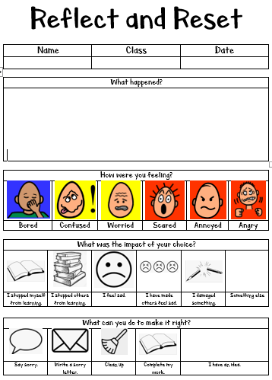

Appendix 2


