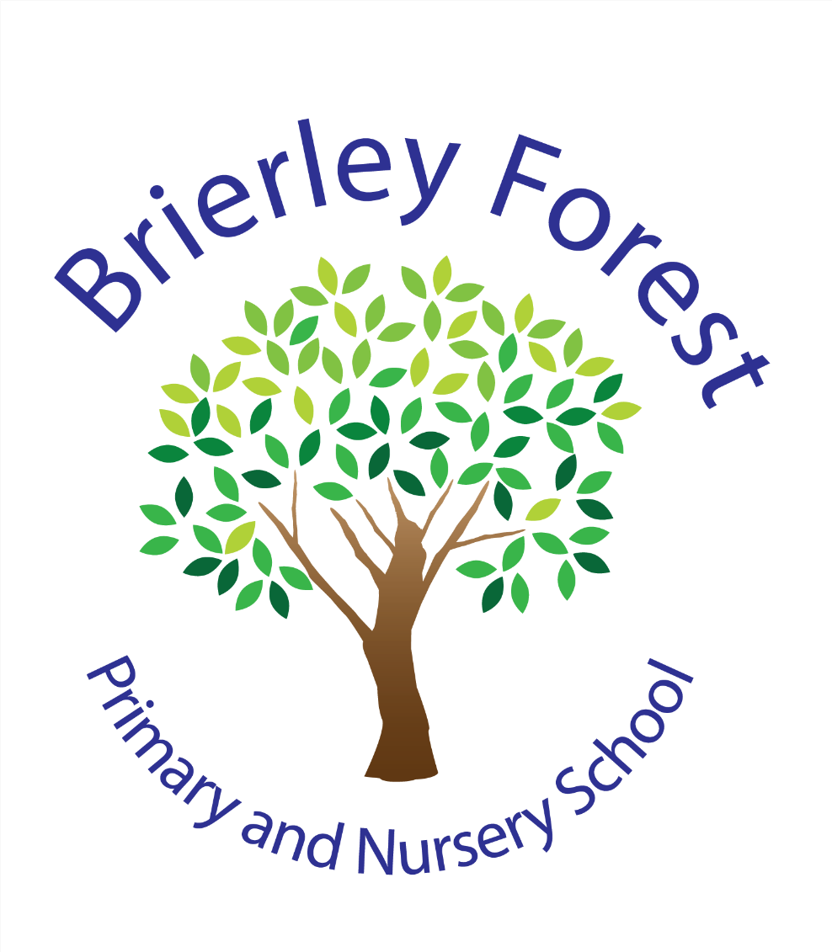

Brierley Forest Primary and Nursery School
Enhanced Provision
Curriculum Alignment



Treehouse Curriculum Mapping and Alignment with the

Brierley Forest KS2 Curriculum

Overview
The Treehouse is Brierley Forest Primary and Nursery School's enhanced provision for Key Stage 2 pupils with complex SEND. The curriculum has been carefully designed to ensure pupils continue to access the same ambitious curriculum as their peers whilst receiving the adaptations, scaffolds and additional support necessary for success.
The curriculum within the Treehouse is not a separate curriculum. Rather, it is an adapted pathway through the school's curriculum that enables pupils to access learning at an appropriate developmental stage whilst maintaining high expectations and broad curriculum entitlement. The provision balances academic learning with communication, independence, personal development and preparation for adulthood skills.

Curriculum Intent
The intent of the Treehouse curriculum is to:
- Provide access to the same ambitious curriculum framework as the rest of the school.
- Develop communication, literacy and numeracy skills through carefully sequenced teaching.
- Enable pupils to access wider curriculum subjects through meaningful and engaging themes.
- Develop independence, social communication and emotional regulation skills.
- Prepare pupils to apply learning successfully in real-life situations.
- Ensure pupils are equipped with the knowledge, skills and confidence needed for future education and daily life.
Whilst pupils may be working significantly below age-related expectations, they continue to access learning drawn from the same curriculum principles, subject disciplines and progression models as their peers.

Consistency with the Whole-School Curriculum
The Treehouse curriculum aligns closely with the wider Brierley Forest curriculum.

Mathematics
The Treehouse follows the same Ark Maths Mastery curriculum used throughout the school.
Teaching begins from pupil's assessed stage of development and understanding. Ongoing Assessment for Learning (AFL) is used to identify gaps in knowledge and determine the most appropriate entry point within the Ark sequence. Pupils therefore access the same mathematical concepts and progression model as their peers, whilst receiving additional repetition, practical experiences, visual supports and scaffolded instruction.
Key principle: Same curriculum, adapted starting points, pace and delivery.

Writing
The Treehouse follows the school's writing curriculum and high-quality text approach, informed by Grammarsaurus Place Value Punctuation and Grammar and Place Value of Spelling.
Pupils engage with carefully selected texts and writing opportunities that mirror the wider school curriculum. Learning is adapted through:
- Smaller-step objectives
- Vocabulary pre-teaching
- Communication support
- Increased modelling
- Additional opportunities for rehearsal and practice
Pupils work towards the same writing purposes and genres as their peers whilst accessing content at a level appropriate to their developmental stage.
Key principle: Same curriculum intent and writing outcomes delivered through adapted teaching approaches.

Reading and Phonics
Many pupils within the Treehouse require continued systematic phonics instruction beyond that typically expected in Key Stage 2. Therefore, the provision includes discrete phonics teaching through the school's structured phonics programme alongside carefully matched reading materials.
As pupils develop secure decoding skills and become fluent readers, they progress beyond phonics provision through one of two pathways:
- Participation in mainstream classroom reading sessions alongside their peers where appropriate.
- Individual 1:1 reading sessions tailored to their needs.
At this stage, teaching increasingly focuses on:
- Reading fluency
- Vocabulary development
- Reading stamina
- Comprehension skills
- Understanding and discussing texts
- Applying reading skills across the wider curriculum
This graduated approach ensures that pupils continue to access the same reading curriculum as their peers whilst receiving the level of support required at each stage of their literacy development. The expectation is that pupils move from learning to read towards reading to learn, enabling greater access to the wider curriculum and promoting independence as readers.
This ensures pupils acquire the foundational literacy skills required to access the wider curriculum.

Curriculum Structure

Discrete Teaching
The Treehouse provides daily teaching in:
- Phonics
- Reading
- Writing
- Mathematics
These subjects are taught discretely to ensure pupils receive systematic instruction and opportunities for consolidation.

Thematic Wider Curriculum
Rather than teaching all foundation subjects separately, wider curriculum learning is organised through engaging half-termly themes.
Examples include:
- Minibeasts
- Twisted Tales
- Great Explorers
- Supertato
- Fairy Tales
- Great Fire of London
Through these themes, pupils access learning from:
- History
- Geography
- Science
- Art
- Design Technology
- Computing
- RE
- PSHE
This thematic approach helps pupils make meaningful connections between subjects and enables concepts to be revisited repeatedly in different contexts.

Science
The Treehouse covers a range of scientific content closely aligned to KS2 National Curriculum expectations, including:
- Plants
- Animals including humans
- Light
- Forces
- Magnets
- Materials
- Living things and their habitats
Treehouse science is adapted through practical and experiential approaches whilst ensuring pupils continue to develop scientific knowledge and enquiry skills.

RE, PSHE and PE
Treehouse pupils access:
- Religious Education
- Personal, Social and Health Education
- Physical Education
These subjects follow the same whole-school curriculum framework whilst being adapted to meet communication, learning and sensory needs. Themes such as relationships, wellbeing, citizenship, safety and diversity remain consistent with the wider school curriculum.

Shared Curriculum Principles
The Treehouse curriculum and wider Brierley Forest curriculum share the same educational principles:
- High expectations for all learners
- Use of high-quality texts
- Vocabulary and communication development
- Building knowledge over time
- Opportunities for retrieval and application
- Promotion of cultural capital
- Development of personal, social and emotional wellbeing
- Online safety and responsible technology use
- Preparation for the next stage of education
These shared principles ensure consistency of curriculum intent across the school.

Key Adaptations Within the Treehouse
The primary difference between mainstream provision and the Treehouse is how learning is delivered, not what pupils are entitled to learn.
Adaptations include:
Smaller-step learning – Learning is broken into manageable steps and carefully sequenced to ensure success.
Increased repetition and retrieval - Key concepts are revisited frequently to support long-term retention.
Multi-sensory teaching – Visual, practical and experiential approaches support understanding and engagement.
Flexible outcomes – Pupils work towards personalised outcomes based on their assessed starting points whilst remaining connected to the broader curriculum.

Application of Skills and Life Skills Curriculum
A distinctive feature of the Treehouse curriculum is the inclusion of dedicated Application of Skills/Life Skills sessions.
These sessions allow pupils to apply classroom learning in meaningful real-life contexts, including:
- Cooking and food preparation
- Shopping and community visits
- Money management
- Communication in real-life situations
- Independence skills
- Understanding the local community
- Personal organisation and self-care
These opportunities support the development of functional skills and preparation for adulthood, complementing and extending the academic curriculum rather than replacing it.

Curriculum Consistency Matrix
Curriculum Area | Mainstream KS2 | Treehouse
Mathematics | Ark Maths Curriculum | Ark Maths Curriculum delivered from an individually assessed starting point
Writing | Whole school writing curriculum and Grammarsaurus text spine | Same curriculum adapted through smaller steps and personalised outcomes
Reading | Whole-class reading and phonics where required | Discrete phonics and reading matched to individual needs
Science | National Curriculum content | Same concepts taught through adapted thematic learning
History | Subject-specific teaching | Subject content taught through themes
Geography | Subject-specific teaching | Subject content taught through themes
Art and DT | Discrete curriculum units | Integrated practical learning linked to themes
RE | Whole-school curriculum | Same curriculum adapted for accessibility
PSHE | Whole-school curriculum | Same curriculum with additional emphasis on independence and regulation
Life Skills | Embedded opportunities | Explicit weekly application of skills sessions

Conclusion
The Treehouse curriculum remains fully aligned with the intent, ambition and breadth of the wider Brierley Forest curriculum. Pupils continue to access the same curriculum areas as their peers, including mathematics, English, science, history, geography, RE, PSHE, PE, art and DT. The curriculum is adapted through thematic delivery, personalised starting points, enhanced communication support, practical learning opportunities and dedicated life skills teaching.
By following the same Ark Maths curriculum, the same Grammarsaurus writing curriculum and carefully mapped wider curriculum content, the Treehouse ensures consistency with whole-school provision whilst providing the specialist approaches required for pupils with complex SEND to succeed.

