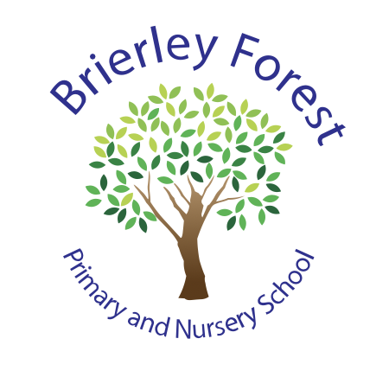

BRIERLEY FOREST PRIMARY AND NURSERY SCHOOL

Treehouse Enhanced Provision Policy
2026-27

The Treehouse
The Treehouse is an enhanced provision within Brierley Forest Primary and Nursery School designed to support children who benefit from a more personalised approach to learning and development.
The provision offers a nurturing, structured and supportive environment where children can access learning in a way that is tailored to their individual strengths and needs. With a reduced ratio of children to adults, staff are able to provide additional support, flexibility and opportunities for children to learn at their own pace.
The Treehouse is staffed by two highly experienced Teaching Assistants who have many years of experience working with children with additional needs. They work closely with the SENCO, class teachers and families to ensure each child receives the support they need to thrive.
Our aim is for every child to feel safe, understood and successful, while developing the confidence, independence and skills needed to achieve their full potential.

Who can attend The Treehouse?
The Treehouse is intended for children whose special educational needs mean they require a higher level of support than can typically be provided within a mainstream classroom for parts of the school day.

Admission to The Treehouse is based on careful assessment of a child's individual strengths, needs and barriers to learning. Children may have a range of identified needs, including difficulties relating to:
- Communication and interaction
- Cognition and learning
- Social, emotional and mental health
- Sensory and/or physical needs
The Treehouse is not a separate school or a permanent placement. Instead, it provides a flexible approach that responds to the changing needs of each child.

What Does a Typical Day Look Like?
Every child's timetable is personalised according to their individual needs.
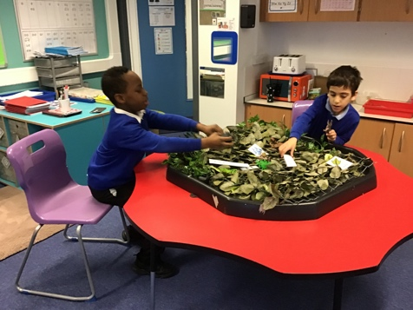
Morning sessions include a focus on phonics and reading, maths and writing. Afternoon sessions include wider curriculum subjects delivered through a theme approach and further enrichment opportunities.
Many children access a hybrid provision, spending some of their day learning within The Treehouse and some of their day in their mainstream classroom. The balance of Treehouse and mainstream time is carefully planned and regularly reviewed.
This flexible approach allows children to access targeted support when needed while remaining part of their wider class and school community.

What Is Learning Like in The Treehouse?
Children in The Treehouse access a broad and ambitious curriculum that is closely aligned with the learning taking place across the school.
Our long-term curriculum plans follow the same themes, key knowledge and learning intentions as those taught in mainstream classes. This ensures children continue to access the same broad curriculum as their peers.
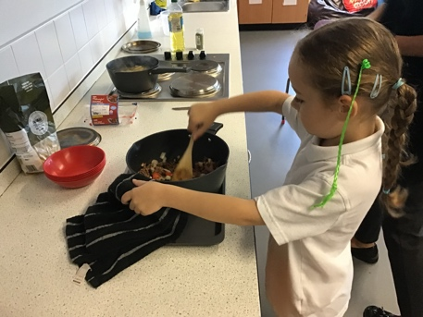
Where The Treehouse differs is in the short-term planning and delivery of learning. Activities are carefully adapted to meet individual needs and often include:
- Practical, hands-on learning experiences
- Experiential learning opportunities
- Small-group and individual teaching
- Additional visual supports
- Flexible learning approaches
- Structured opportunities to revisit and consolidate learning
This allows learning to be meaningful, engaging and accessible while supporting children to develop confidence and independence.

How Is the Curriculum Organised?
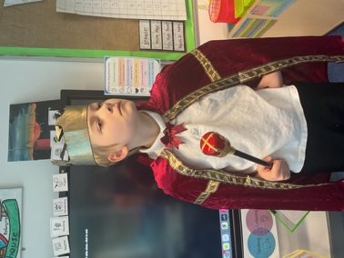
Children access discrete lessons in:
- Mathematics
- Writing
Phonics provision is matched to individual need and may include:
- Individual phonics sessions
- Small-group phonics teaching
- Mainstream phonics groups where appropriate
Wider curriculum subjects are taught through engaging half-termly themes. These themes are based on high-quality texts from the school's English curriculum and link learning across two or three foundation subjects each half term. The children also take part in weekly Life Skills sessions where they are encouraged to develop independence in applying skills they have learned in real-life contexts, like cooking, budgeting and shopping.
This approach helps children make meaningful connections in their learning while building knowledge and skills across the wider curriculum.
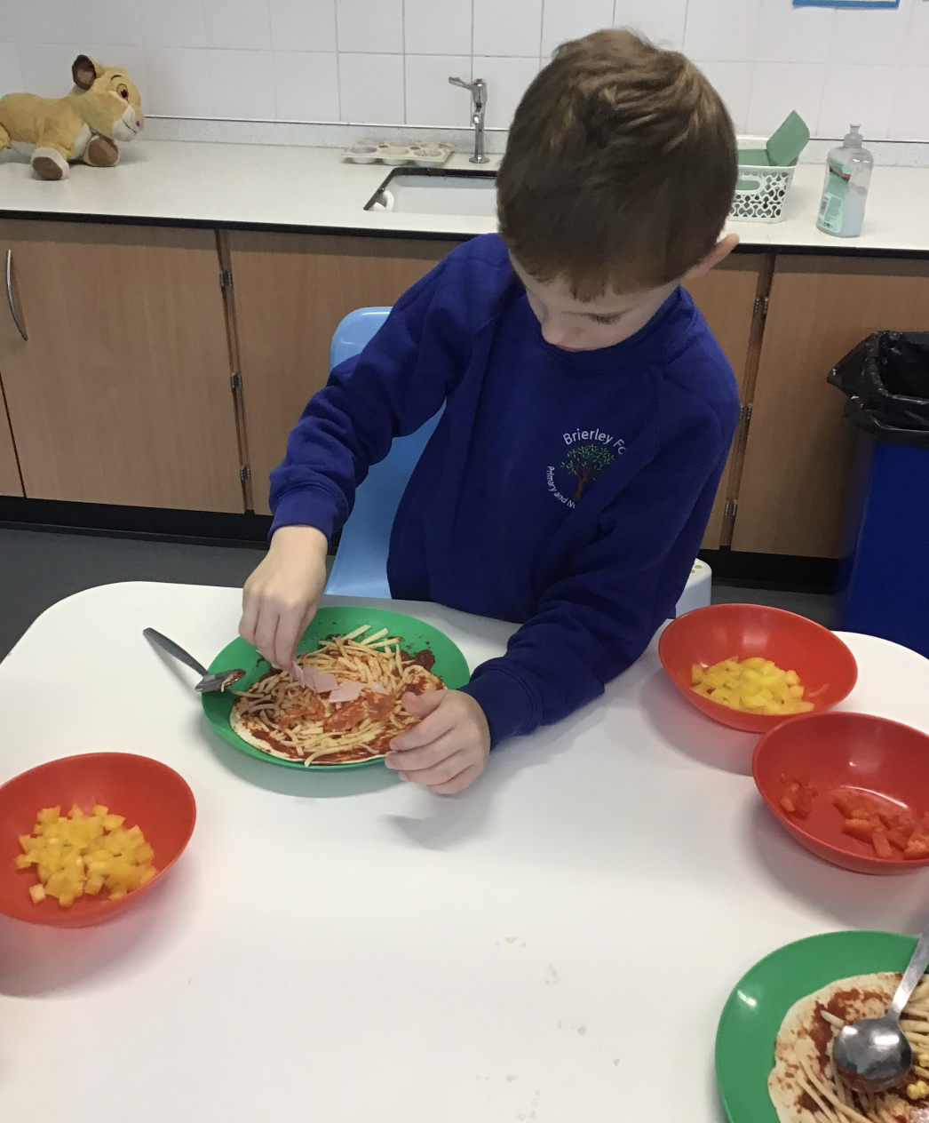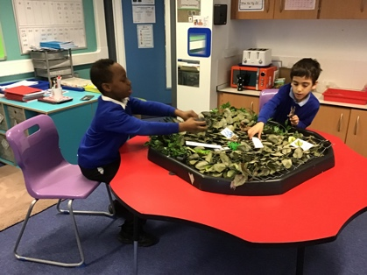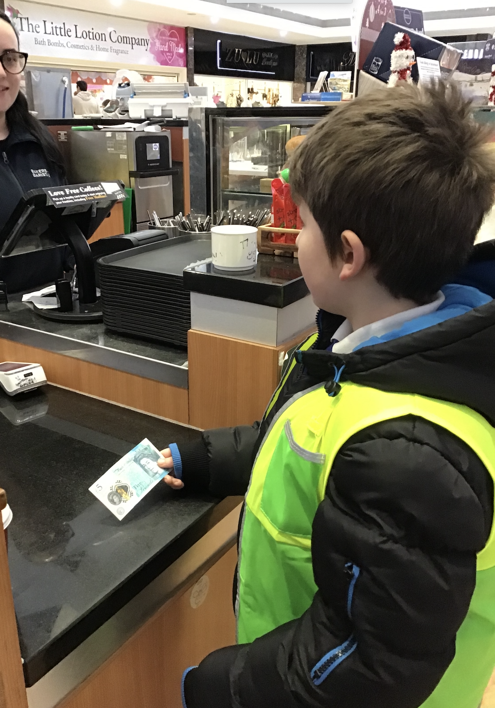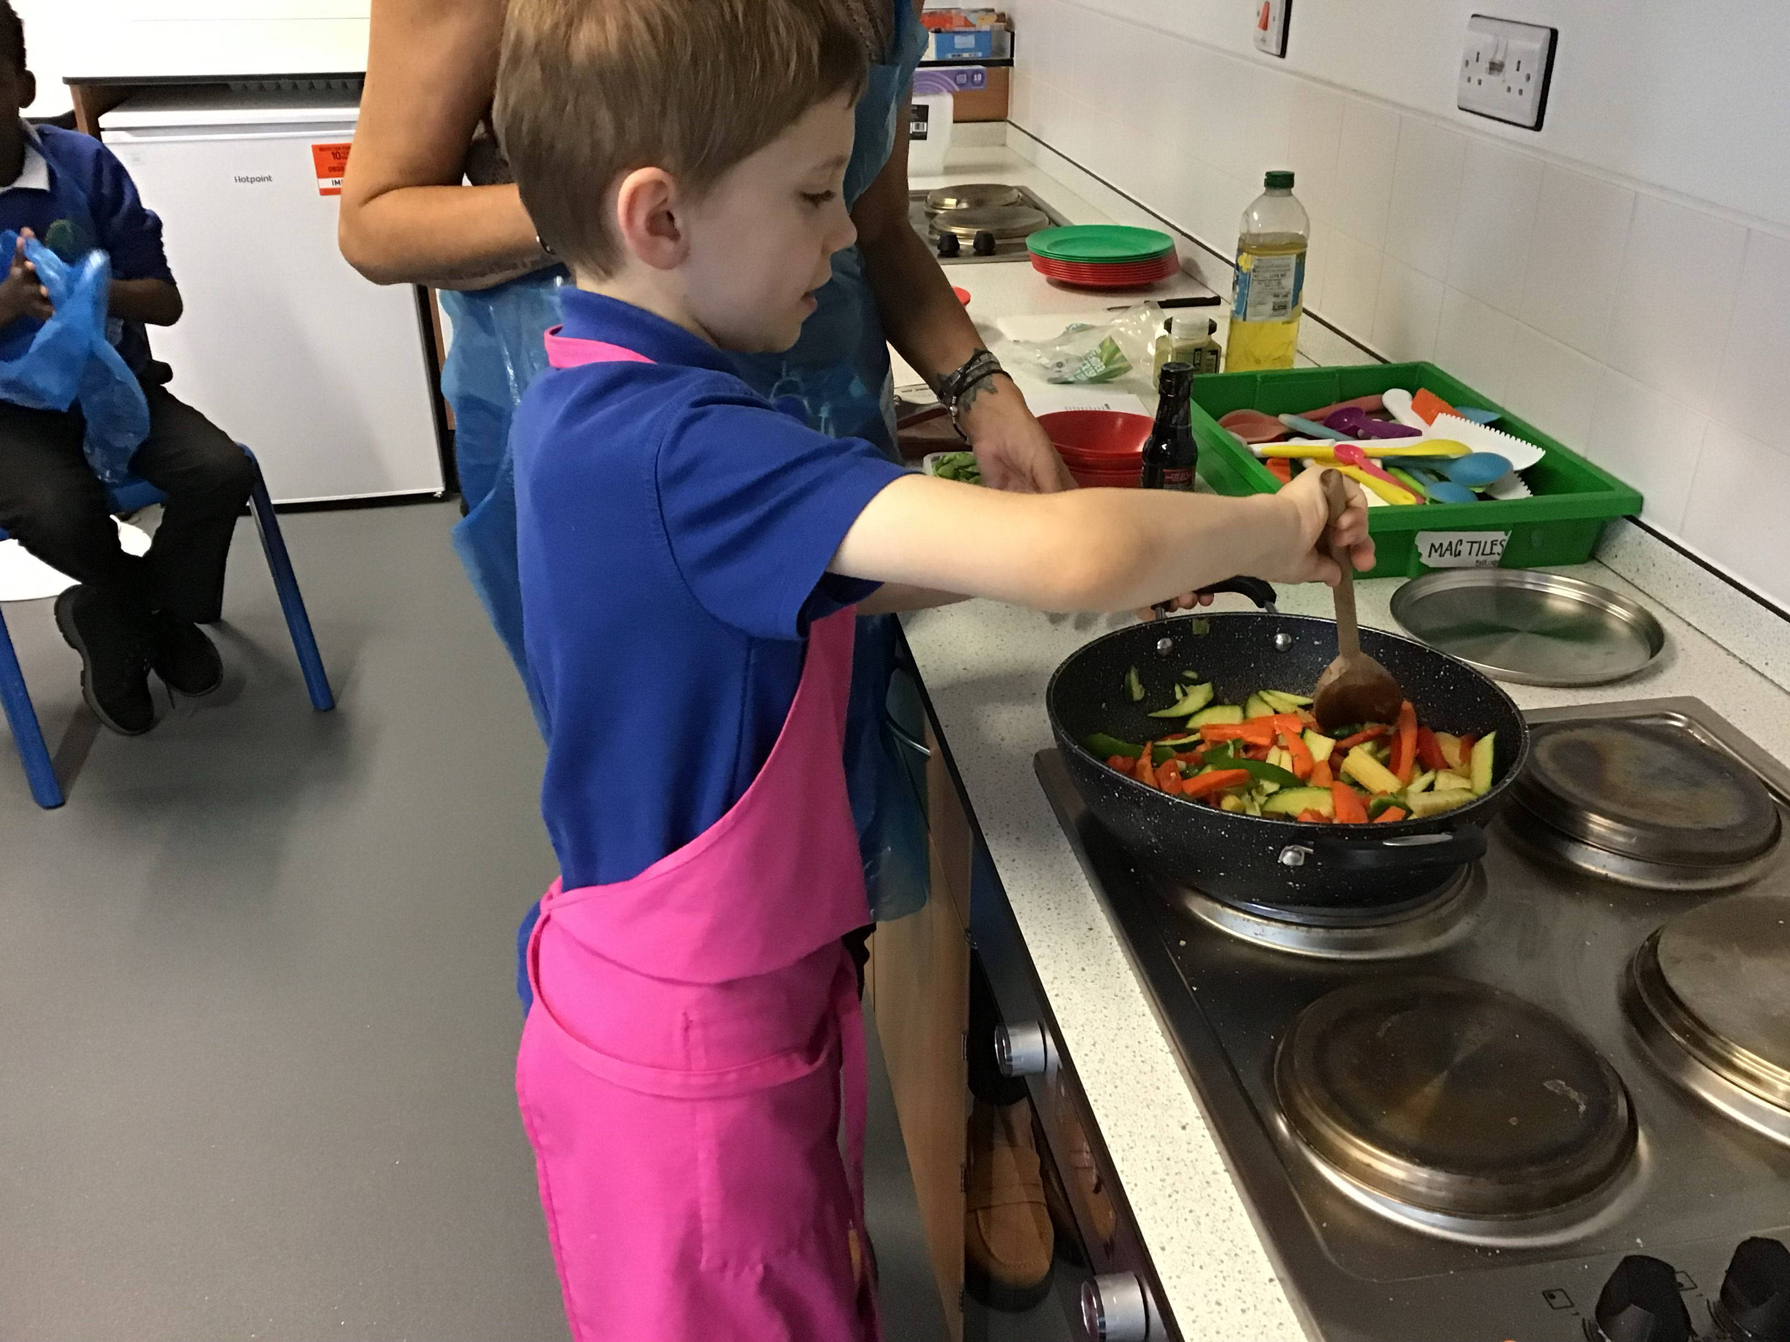

How Are Children's Needs Supported?
The Treehouse takes a flexible and responsive approach to support.
Staff carefully monitor children's learning, wellbeing and development and adapt provision as needs change. Support may include:
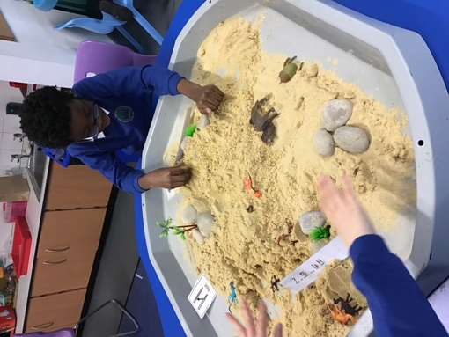
- Personalised learning activities
- Communication support
- Emotional regulation support
- Sensory adaptations
- Structured routines and visual supports
- Additional adult guidance to develop independence
- Opportunities to develop social interaction and friendship skills

How will My Child Still Be Included in School Life?
A key aim of The Treehouse is to help children remain connected to their peers and the wider school community.
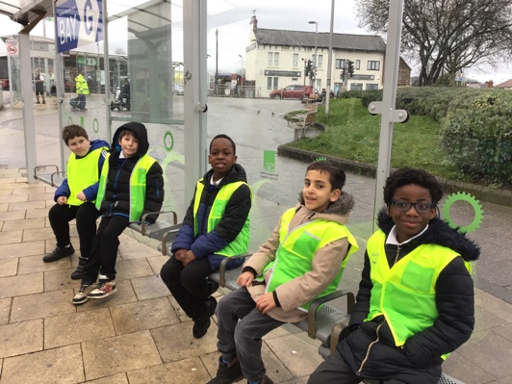
Children are encouraged and supported to participate in:
- Mainstream learning opportunities
- Assemblies
- Educational visits
- School performances
- Special events
- Clubs and enrichment activities
- Playtimes and social opportunities
We believe these experiences play an important role in developing confidence, independence, friendships and a sense of belonging.

How Is Success Measured in The Treehouse?
In The Treehouse, we recognise that success looks different for every child.
We measure success by looking at the progress children make from their individual starting points. This includes:
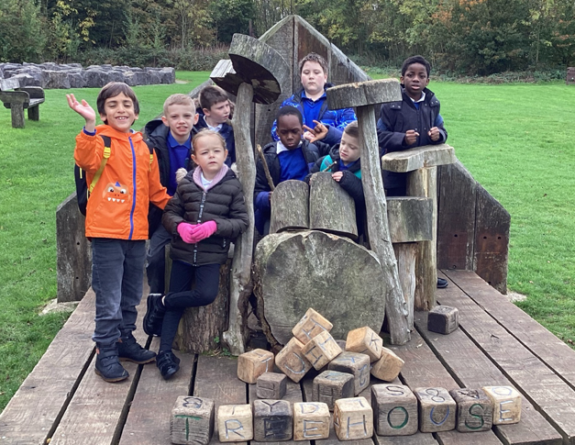
- Progress towards individual targets and outcomes
- Improved communication and interaction skills
- Increased confidence and independence
- Improved emotional regulation and wellbeing
- Greater engagement in learning
- Development of positive relationships with peers and adults
- Increased participation in mainstream learning and school life
- Progress within the curriculum
We celebrate both small steps and significant achievements, recognising that every child's journey is unique. Children's progress is regularly reviewed by The Treehouse team, class teachers, the SENCO and parents to ensure provision continues to meet their needs.

Working in Partnership with Families
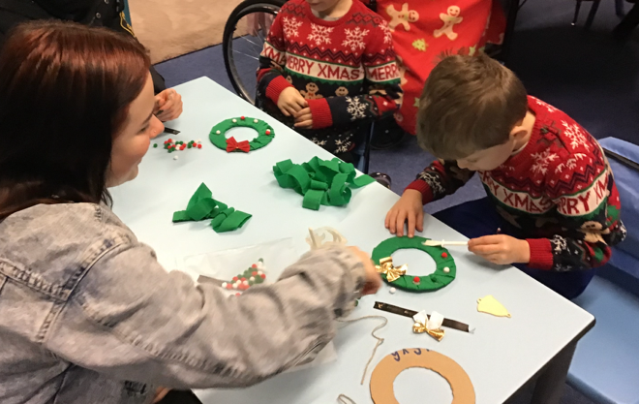
Positive relationships between home and school are essential to a child's success. We value the knowledge and expertise that parents and carers bring and aim to work closely together to support every child.
We look forward to celebrating successes, sharing progress and working in partnership with families throughout each child's journey in The Treehouse.

