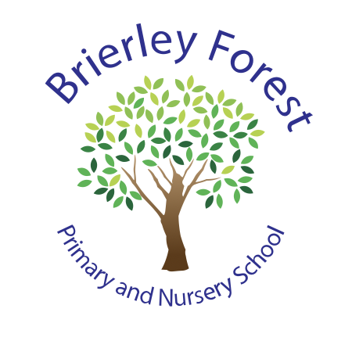

BRIERLEY FOREST PRIMARY AND NURSERY SCHOOL

SEND Information Report

2026-27



At Brierley Forest Primary and Nursery School, we believe that every child deserves to feel valued, included and successful. We recognise that all children learn differently, and some may need additional support to help them reach their full potential.
As a school, we are committed to working closely with parents, carers, children and outside professionals to ensure every child receives the support they need to thrive academically, socially and emotionally.
We understand that navigating the SEND process can sometimes feel overwhelming. This report aims to explain, in clear and accessible language, how we identify and support children with Special Educational Needs and Disabilities (SEND) at Brierley Forest.
We hope this information helps you understand what support is available and who you can speak to if you have any questions or concerns. We believe that the best outcomes for children are achieved when families and school work together as a team.
If you would like further information about SEND provision in our school, please contact our SEND Team, who will be happy to help.

1. What types of SEND does the school support?
At Brierley Forest, we support children with a wide range of special educational needs and disabilities. Children's needs may fall into one or more of the following areas:
Communication and Interaction  Children who may find it difficult to communicate, understand language, engage socially or interact with others. | Cognition and Learning  Children who may learn at a slower pace than their peers or need additional support with reading, writing, maths or other areas of learning.
Social, Emotional and Mental Health  Children who may experience difficulties managing emotions, behaviour, relationships, anxiety, self-esteem or wellbeing. | Sensory and/or Physical Needs  Children who may have physical disabilities, medical needs or sensory differences that affect how they access learning and the school environment.

Every child is unique, so support is always tailored to their individual strengths and needs.

2. Who will support my child?
Every child at Brierley Forest is supported by their class teacher and the wider staff team.
Assistant Headteacher and SENCO - Mrs Smedley oversees SEND provision across the school and works closely with staff, families and outside professionals to ensure children receive the support they need.
Assistant SENCO - Mrs Durkin works alongside Mrs Smedley to support pupils, families and staff, helping to coordinate provision and monitor progress.
Class teachers are responsible for ensuring teaching is adapted to meet individual needs and that progress is monitored regularly.
Our skills teaching assistants provide support within classrooms, through small group interventions and through individual programmes where appropriate.
We regularly provide training so that staff can continue developing their knowledge and skills. This may include:
- Autism and neurodiversity
- Speech and language development
- Social, emotional and mental health needs
- Medical needs
- Positive behaviour support
- Attention Autism
- Communication strategies
- Sensory needs
We value the expertise of parents and carers and recognise that you know your child best. We will always work in partnership with you when planning support.

3. What should I do if I think my child may have SEND?
If you have concerns about your child's learning, development, behaviour or wellbeing, please speak to your child's class teacher in the first instance.
Together, we will:
- Listen to your concerns
- Discuss your child's strengths and needs
- Agree initial support strategies
- Monitor progress over an agreed period of time
If further support is needed, we may involve the SENCO and, where appropriate, seek advice from specialist professionals. Parents will always be involved in these discussions and decisions.
You can also contact the SEND Team directly through the school office or by emailing:
bforestsenco@bforest.notts.sch.uk

4. How do we identify SEND?
At Brierley Forest, we know that every child develops and learns at their own pace. Sometimes children need extra help to make progress, access learning or manage social and emotional situations.
We identify SEND in a range of ways, including:
- Discussions with parents and carers
- Information from previous schools or settings
- Teacher observations
- Progress and attainment information
- Attendance and wellbeing information
- Assessments and screening tools
- Advice from external professionals
Children do not need a medical diagnosis to receive support in school. If we believe a child may need additional help, we will work closely with families to understand their strengths and needs and agree the best support.

5. How do we decide what support my child needs?
We follow a process called the Graduated Approach, which helps us plan, deliver and review support effectively.
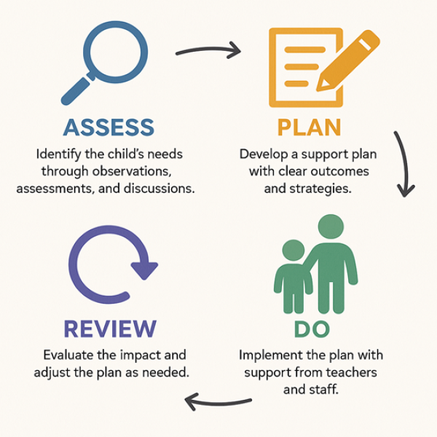
- Assess: This stage involves identifying a child's needs through observation, assessment, and gathering information from parents and other professionals.
- Plan: A plan is developed to outline the specific support and provision required to address the identified needs.
- Do: The planned provision is put into action, with the setting providing the necessary support and resources.
- Review: The effectiveness of the provision is reviewed regularly, and the plan is adjusted as needed to ensure the child is making progress and achieving their goals.
This cycle is repeated with each review and helps ensure support remains appropriate and responsive to your child's needs.

6. How will I be involved in my child's SEND support?
We believe children achieve the best outcomes when schools and families work together.
Parents and carers may be involved through:
- Parents' evenings
- SEND review meetings
- Annual Reviews for children with an EHCP
- Meetings with the SENCO
- Home-school communication
- Sharing information from home
- Joint target setting and review discussions
We value your views and recognise that you know your child best.

7. How will my child be involved?
We encourage children to share their views about school, learning and the support they receive.
Depending on their age and needs, children may:
- Share their likes, dislikes and interests
- Discuss what helps them learn
- Contribute to review meetings
- Help set targets and outcomes
- Talk about their aspirations and goals
We want every child to feel listened to, respected and involved in decisions that affect them.

8. What additional support is available at Brierley Forest?
Most children with SEND have their needs met through high-quality teaching and targeted support within the classroom.
Some children may also receive:
- Small group support
- Speech and language programmes
- Precision teaching
- Phonics interventions
- Social skills groups
- Nurture and emotional wellbeing support
- Sensory support
- Individual programmes designed around specific needs
Support is always tailored to the individual child.

9. What is The Treehouse?
The Treehouse is Brierley Forest's enhanced provision for children with complex SEND needs who require a more personalised approach to learning.
The Treehouse offers:
- Smaller group sizes
- Higher levels of adult support
- Personalised learning opportunities
- Support for communication and interaction
- Emotional regulation support
- Sensory-informed practice
- Opportunities to develop independence and life skills
The Treehouse curriculum is closely linked to the whole-school curriculum. Learning is carefully adapted so that children can access meaningful and engaging experiences while working towards ambitious outcomes.
Children in The Treehouse remain an important part of the wider school community, and opportunities for inclusion are carefully planned according to individual needs.

10. How do we support emotional wellbeing?
A child's emotional wellbeing is as important as their academic progress.
Support may include:
- Meet and greet sessions
- Emotion coaching
- Nurture approaches
- Emotional regulation strategies
- Safe spaces and sensory breaks
- Positive relationships with trusted adults
- Small group wellbeing interventions
- Support during transitions and less structured times
We aim to help children feel safe, understood and ready to learn.

11. Which outside agencies might be involved?
Sometimes we seek advice from specialist services to better understand and support a child's needs.
These may include:
- Educational Psychology Service
- Speech and Language Therapy
- Healthy Families Team
- Schools and Families Specialist Services
- Occupational Therapy
- Physiotherapy
- CAMHS
- Autism Team
- Behaviour Support Services
Parents and carers will always be involved in discussions about referrals and recommendations.

12. How do we support transitions?
Changes can be challenging for some children, so we carefully plan transitions.
This may include:
- Additional visits
- Transition meetings
- Visual timetables and transition booklets
- Photographs of new environments
- Meetings with new teachers
- Personalised transition plans
- Enhanced transition arrangements for secondary school
We work closely with families and receiving settings to make transitions as successful as possible.

13. What is an Education, Health and Care Plan (EHCP)?
An Education, Health and Care Plan (EHCP) is a legal document that describes a child or young person's education, health and care needs and the support required to meet those needs.
Most children's needs can be successfully supported through the resources available within school. However, for a small number of children with significant and complex needs, an Education, Health and Care Needs Assessment may be requested from the Local Authority.
Parents can also request an assessment themselves.
The SENCO can provide advice and guidance throughout this process.

14. How do we know if support is making a difference?
We regularly monitor and review children's progress using a range of information, including:
- Classroom observations
- Assessment information
- Individual targets and outcomes
- Intervention records
- Attendance and wellbeing information
- Parent feedback
- Pupil voice
We celebrate progress in all areas, including academic achievement, communication, independence, confidence and emotional wellbeing.

15. How accessible is the school?
We are committed to ensuring all children can access school life and learning opportunities.
Our school provides:
- Accessible entrances and facilities
- Adapted resources and equipment where required
- Reasonable adjustments to support individual needs
- Visual supports and communication aids
- Sensory-friendly approaches where appropriate
- Individual risk assessments when required
Further information can be found in the school's Accessibility Plan.

16. What should I do if I am unhappy with the support my child receives?
We always encourage parents and carers to speak with us if they have any concerns.
The best first step is to speak with:
- Your child's class teacher
- The SENCO
- A member of the Senior Leadership Team
We will always aim to work together to resolve concerns quickly and positively.
If concerns remain, parents may follow the school's Complaints Policy, which is available on the school website.

17. Frequently Asked Questions
Does my child need a diagnosis to receive SEND support?
No. Children can receive support based on their individual needs without a formal diagnosis.
How often will my child’s support be reviewed?
Support is reviewed regularly through the graduated approach and through meetings with parents.
Will my child always remain on the SEND register?
Not necessarily. If a child no longer requires support that is different from or additional to that provided for most children of the same age, they may be removed from the SEND Register following discussion with parents.
Who should I contact if I have concerns?
Your first point of contact should be your child's class teacher. You can also contact the SENCO through the school office.
Where can I find more information?
Further information is available through the Nottinghamshire Local Offer and from the school's SEND Team.
https://www.nottinghamshire.gov.uk/education/special-educational-needs-and-disabilities-send/special-educational-needs-and-disabilities-send

Contact Details
SENCO: Emma Smedley (Assistant Headteacher and SENCO)
Assistant SENCO: Mrs Durkin
Email: bforestsenco@bforest.notts.sch.uk
School Telephone: 01623 553189
Website: https://brierleyforestprimary.web12.juniperwebsites.co.uk

