Useful Websites to help our children stay safe
  https://www.thinkuknow.co.uk/ | Thinkuknow is the education programme from CEOP, a UK organisation which protects children both online and offline. |   https://parentzone.org.uk/ | Parent Zone are the experts in digital family life. They provide support and information to parents, children and schools about how to navigate the internet safely and confidently.  They have a great Digital Parenting Magazine.
  https://www.anti-bullyingalliance.org.uk/ | The Anti-Bullying Alliance is a group of organisations and individuals which have a shared vision to stop all forms of bullying between children and young people. | 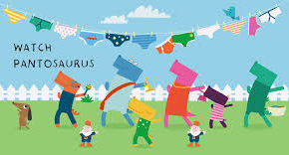  https://www.nspcc.org.uk | Let’s Talk Pants  With the help of a friendly dinosaur Pantosaurus, talking PANTS is a simple way to teach your child how to stay safe from abuse.
  https://www.bbc.co.uk/cbbc/findoutmore/stay-safe-facts | Top Tips from CBBC for staying safe online. |   https://www.childnet.com/resources/smartie-the-penguin | Smartie, the Penguin An online safety story for 3 to 7 year olds. Join in with Mummy Penguin's song and follow the adventures of Smartie the Penguin as he learns how to be safe online.

