Brierley Forest Primary and Nursery School

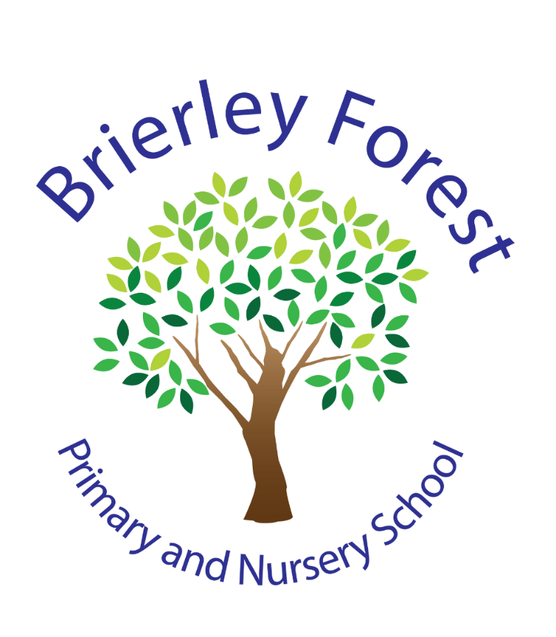

Nursery Charging Policy

Aims
To clarify when children will be admitted to the Nursery using the eligibility criteria set out by the Free Early Education Entitlement.
- To make clear the process for securing a place in our nursery.
- To outline the working hours of the Nursery and the session options available to families.
- To confirm when additional hours can be purchased, the cost of this and how it should be paid.
Basic Eligibility Criteria
All three- and four-year-olds can take up a place of fifteen hours per week of the Free Early Education Entitlement, term time only, in the Nursery.
Some three- and four-year-olds may also be entitled to thirty hours free education if they have working parents/carers.
Families can check if they are eligible for this through the Childcare Choices Website:
www.childcarechoices.gov.uk
Children are funded the term after their third birthday. The funding start dates are as followed.
Your child’s date of birth | When you become eligible for a free place
Children born between 1st January – 31st March | The beginning of term on or after 1st April
Children born between 1st April – 31st August | The beginning of term on or after 1st September
Children born between 1st September to 31st December | The beginning of term on or after 1st January

Sessions offered
At our Nursery we offer the following options to claim the 15 hours funding.
Option | Funded hours | Timings
AM | 15 hours | Monday to Friday 8.45am – 11.45am
PM | 15 hours | Monday to Friday 12.30pm – 3.30pm

If children are eligible for 30 hours they be offered our full day.
Option | Funded hours | Timings
Full day | 30 hours | Monday to Friday 8.45am – 3.15pm

Charging for additional hours
Additional hours are sessions in Nursery over and above each child’s free entitlement of fifteen hours per week (where they are not accessing the 30-hour entitlement). Space permitting, families of children in our Nursery will have the opportunity to purchase additional sessions to extend their child’s day in nursery to our full day.
Charges
- Additional sessions are charged at a rate of £20 per session. These will extend the day to our full day of 8.45am-3.15pm.
- As the children attend nursery over dinner time, they will either need to bring a packed lunch or purchase a school dinner at an extra cost of £2.53.
- Additional hours must be booked and paid for in advance using ParentPay at least 7 days before the session they would like to attend.
- Priority in allocation of hours will always be given to children attending for the Free Early Education Entitlement before chargeable additional hours will be considered.
- Additional chargeable sessions will then be allocated on a first-come, first-serve basis depending on places available.
- Where payment has not been given, children will not be able to attend any additional sessions.
- Payment will still be taken IN FULL for your childcare even if your child is off sick or on holiday, due to the staffing being arranged prior to look after your children.
- If the nursery is closed for any reason (i.e. inset day or bad weather) you WILL NOT be charged for childcare that day.
- Any revision to the additional hour’s prices will be notified to parents/carers the term prior to the new charge taking effect.

Procedure for administrating additional hours for children already in school
- EYFS Lead will liase with the school office about available places for each half-term.
- The school office team will add available sessions onto ParentPay for the next half-term with a deadline of one week before each paid session.
- Before the deadline, families request additional hours that they would like their child to attend the following week. These can be booked for the whole half-term in advance should you so wish. Fees will need to be paid at the time of booking.
- Once selected and paid for, parents have agreed that they have read the Nursery charging policy and understand this.
- The child’s name is added to the school register for all sessions they will be attending.
- Sessions must be booked at least 7 days prior. Once booked, sessions cannot be changed.

Ad-hoc Sessions
Where sessions have not been booked 7 days in advance and families would like their child to attend an extra session at short notice, ad-hoc sessions may be available. Families should liase with the EYFS Lead/School office for availability for this. Should this be offered, this will need to be paid in full before your child attends the session.
It is wise to give as much notice as possible when requesting an ad-hoc session to increase the chances of availability.
Attendance
Attendance in the Nursery will be monitored, with the same expectations of ninety six percent attendance across the academic year in Nursery, in line with whole school expectations. Parents and carers are informed that they must notify the school in the case of absence and suitable reasons given to authorise the absence. Parents and carers must fill in a leave of absence form and return to the school should they wish to take their child on holiday during term time.
If a child is absent from nursery during a pre-paid chargeable session, the school WILL NOT be able to give a refund.
Unavoidable closure of the school
Should the school be closed for reasons beyond our control you will receive a refund for any sessions affected.
Notice Period
As we are requesting you pay at least a week in advance. There will be no notice period required. Once sessions have been paid for, there is an expectation that children will attend. If children do not attend the session the children will be marked as absent, and this will not be refunded.

