The Brierley Way –
Early Years Foundation Stage (EYFS)
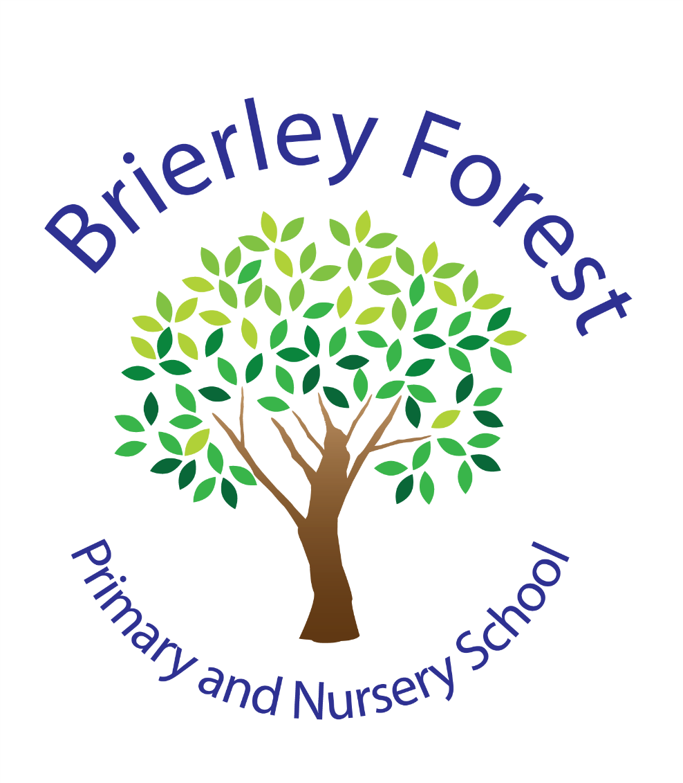

Learn and Grow Together
At BFPNS, we create a caring family of resilient learners, enabling all individuals to thrive in our community.
Belonging, Caring, Resilience, Integrity

Contents
1. Introduction 3
2. Aims 3
3. Legislation 3
4. Structure of the EYFS 4
5. Curriculum 4
5.1 Planning 6
5.2 Teaching 6
6. Assessment 7
7. Staff 9
7.1 Staff training 9
7.2 Safer recruitment 10
7.3 Whistleblowing 10
8. Safeguarding and welfare procedures 10
8.1 Before joining our school 11
8.2 Staffing 11
8.3 Attendance/Absence 11
8.4 Oral health and tooth brushing 12
8.5 Safer eating and Nutrition 12
8.6 First Aid 12
8.7 Designated safeguarding lead (DSL) 13
8.8 Toilet and Privacy 13
9. Monitoring arrangements 13
Appendix 1. List of statutory policies and procedures for the EYFS 14

Introduction
The Early Years Foundation Stage (EYFS) applies to children from birth to the end of the reception year. In the early years at Brierley Forest Primary and Nursery School we aim for our children to be happy, confident, and well-rounded individuals with a love for learning. We support them to fulfil their potential in a safe, secure and stimulating environment which is carefully planned to build on their needs and interests. At BFPNS we aim to build and embed a culture of respect for ourselves, others and the environment, readiness to learn and the safety of ourselves and others.

“Every child deserves the best possible start in life and the support that enables them to fulfil their potential. Children develop quickly in the early years and a child’s experiences between birth and age five have a major impact on their future life chances. A secure, safe and happy childhood is important in its own right.”

2. Aims
This policy aims to ensure:
- That children access a broad and balanced curriculum that gives them the broad range of knowledge and skills needed for good progress through school and life
- That children access a secure and safe indoor and outdoor environment which supports learning.
- Quality and consistency in teaching and learning so that every child makes good progress, and no child gets left behind
- A close working partnership between staff and families to encourage independent, happy learners who thrive in school and reach their full potential from their various starting points.
- Every child is included and supported through equality of opportunity and anti-discriminatory practice

3. Legislation
This policy is based on requirements set out in the statutory framework for the Early Years Foundation Stage (EYFS) (For group and school-based providers) that was updated in July 2025 (Effective September 2025).

The framework covers the education and care of all children in early years provision, including children with special educational needs and disabilities (SEND).

Within this framework there are four guiding principles which shape our practice. These are:
- Every child is a unique child, who is constantly learning and can be resilient, capable, confident, and self-assured.
- Children learn to be strong and independent through positive relationships.
- Children learn and develop well in enabling environments with teaching and support from adults, who respond to their individual interests and needs and help them to build their learning over time. Children benefit from a strong partnership between practitioners and families.
- Children develop and learn at different rates. The framework covers the education and care of all children in early years provision, including children with special educational needs and disabilities (SEND).

4. Structure of the EYFS
At Brierley Forest Primary and Nursery School, our Early Years provision accommodates children between the ages of 3 to 5 years. We take children into our Nursery the term after their third birthday. In nursery we currently offer places for 15-hour universal funding and additionally the 30-hour extended funding for those that are eligible. We also offer additional paid for sessions for our nursery children where we have these available. We have the capacity to offer 2 Reception classes, offering a total of up to 60 full time school places.

The school gate opens at 8.40am and our reception children’s school day runs from 8.45am-3.15pm. Nursery children will attend either a morning session which runs from 8.45am-11.45am or an afternoon session which runs from 12.30pm-3.30pm. Any 30 hour funded children follow the time of the typical school day 8.45am-3.15pm.

The children in Nursery and Reception currently share a space to play and learn alongside each other in a purposeful and age-appropriate environment. They also have access to a large shared outdoor space where they can free flow throughout the day.

5. Curriculum
Our early years setting follows the curriculum as outlined in the latest version of the EYFS statutory framework that applies from September 2025.

The EYFS framework includes 7 areas of learning and development that are equally important and inter-connected. However, 3 areas known as the prime areas are seen as particularly important for igniting curiosity and enthusiasm for learning, and for building children’s capacity to learn, form relationships and thrive.

The prime areas are:

Communication and Language | Listening, Attention and Understanding  Speaking
Physical Development | Fine motor  Gross motor
Personal, Social and Emotional Development | Self-regulation  Managing Self  Building Relationships

The prime areas are strengthened and applied through 4 specific areas:

Literacy | Writing  Word Reading  Comprehension
Mathematics | Number  Numerical Patterns
Understanding the world | Past and Present  The Natural World  People, Culture and Communities
Expressive Arts and Design | Creating with Materials  Being Imaginative

The EYFS also includes the ‘Characteristics of Effective Learning’ which underpin our curriculum and help practitioners identify a child’s attitude to learning and their ability to play, explore and think critically about the world around them.
The three characteristics are:

- Playing and Exploring - children investigate and experience things, and ‘have a go’
- Active Learning - children concentrate and keep on trying if they encounter difficulties, and enjoy achievements
- Creating and Thinking Critically - children have and develop their own ideas, make links between ideas, and develop strategies for doing things

At Brierley Forest Primary and Nursery School we believe that a great curriculum is one that motivates and inspires our children. Our curriculum has been designed across the whole school to recognise children’s prior learning from previous settings and their experiences at home, provide first-hand learning experiences, whilst allowing the children to build resilience, ambition and integrity. Every child is valued as a unique individual, and we celebrate and welcome differences within our school community. We believe the ability to learn is underpinned by the teaching of basic skills, knowledge, concepts and values.

5.1 Planning

At Brierley Forest, planning for this curriculum is linked to the whole school overview but is also designed to be flexible so that a child’s unique interests are supported. All areas of the EYFS are followed and planned for to ensure there is a broad, balanced and progressive learning environment and curriculum. We have a two-year rolling programme of themes. Skills and knowledge are planned throughout the year which take into account our themes, the children’s interests, needs and our community. Some sessions including Maths and Phonics (RWI) are planned discreetly whilst the other areas of learning form more of a theme-based approach including high quality texts.

Staff are expected to develop a strong continuous provision, and then plan enhanced provision and additional adult directed activities to support this. As children progress through the early year’s foundation stage a range of whole class, group and independent activities where children can access their learning will be planned, as appropriate for the age and stage of the pupils. Staff reflect on the different ways that children learn and plan activities and experiences for children that enable them to develop and learn effectively, as well as offering them opportunities to develop their cultural capital. Where a child may have a special educational need or disability, staff consider whether specialist support is required, linking with relevant services from other agencies, where appropriate.

5.2 Teaching

At Brierley Forest each area of learning and development is implemented through planned, purposeful play, and through a mix of adult-led and child-initiated activities. Children will have an opportunity to work independently, work collaboratively with their friends and with members of staff.

We plan a balance between children having time and space to engage in their own child-initiated activities and those which are planned by adults. At different points in the day children will engage in whole group, small group or 1:1 activity alongside their independent learning. There are also allocated times for whole class/group daily carpet learning sessions. Phonics is taught daily using Read Write Inc.

During children’s play they have access to a range of stimulating activities which they access independently both indoors and outdoors. We understand how important play is for children’s development, building their confidence as they learn to explore, to think creatively and critically alongside other children as well as on their own. They can practise skills, build upon and revisit prior learning and experience at their own level and pace. Play gives our children the opportunity to pursue their own interests and inspire those around them. The children learn to adapt, negotiate, communicate, discuss, investigate, and ask questions. We believe it is important that adults take an active role in child-initiated play through observing, modelling, facilitating, and extending their play and language using high-quality interactions. In the EYFS we implement the ShREC approach which we use a guide to ensure our interactions with children are of the highest quality.
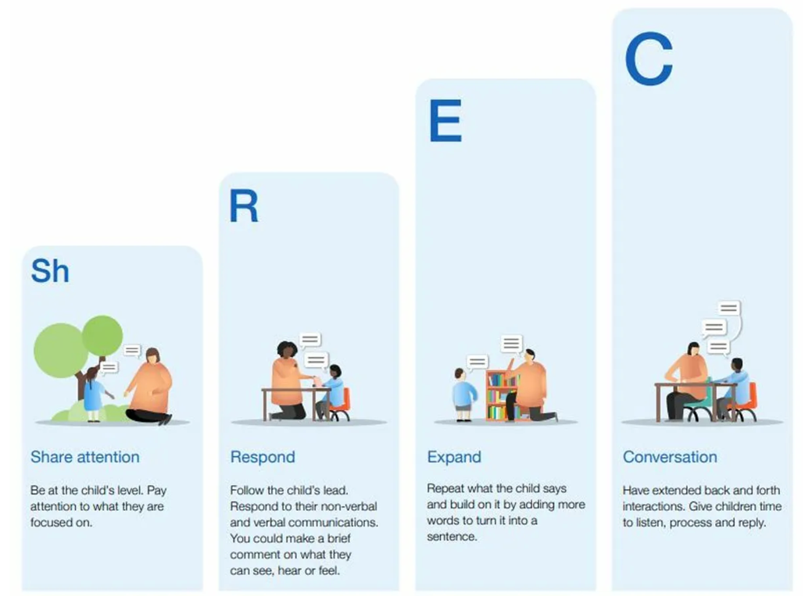

Through observation and discussion, areas of need and next steps are then identified for all children to ensure good progress is made and these are then used to inform teaching in the provision.

As children grow older, and as their development allows, the balance gradually shifts towards more adult-led activities to help children prepare for more formal learning, ready for the next stage of their education.

6. Assessment
At Brierley Forest, ongoing assessment is an integral part of the learning and development processes. As part of daily practice staff observe and interact with pupils to identify their level of achievement, interests and learning styles. Where it is appropriate any written work is kept in the child’s individual book which follows them through the year. These observations are used to shape future planning and ensure that all children build on their current knowledge and skills at a good pace. All adults are expected to show an understanding of what the pupils know and can do, and discussions are held regularly about individual children’s development, progress and their next steps. Adults are regularly expected to discuss this with leaders to ensure we meet the needs of all pupils within the setting and that we adapt timetables, the environment and planning to ensure we continue to be ambitious for all pupils.

During the children’s first half term in the Nursery and Reception classes, the teacher assesses each child’s development and learning attainment against a baseline assessment. This enables practitioners to identify key areas of support from the very beginning and helps us to tailor provision to the needs of each child.

Within the first 6 weeks that a child starts reception, staff will also administer the Statutory Reception Baseline Assessment (RBA).

Throughout the year there are three further assessment points which take place termly. Children in Nursery and Reception are determined to be on track/not on track in their development for the 7 areas of learning. These are informed and moderated by checkpoints put together by the EYFS team which match the curriculum and expectations of child development. This will support identification of attainment but also the gaps for further support and learning. This information is tracked using INSIGHT to ensure good rates of progress for all children, including vulnerable groups such as those with SEND, disadvantaged or summer-born children.

In the final term of the academic year in which the child reaches age 5, staff complete the EYFS profile for each child (before 30 June in that term). Each child is assessed against the 17 early learning goals, indicating whether they are:
- Meeting expected levels of development
- Not yet reaching expected levels (‘emerging’)

The profile reflects ongoing observations, and discussions with families. The results of the profile are shared with families for their child at the end of the reception year as well as with the child’s year 1 teacher. This helps to inform a discussion between reception and year 1 teachers about the child’s stage of development and learning needs and helps with planning activities in year 1.

In exceptional circumstances, after discussion and only in agreement with parents and/or carers, a child might stay in EYFS provision beyond the end of the academic year in which they turn 5. In these exceptional cases, we will continue to assess the child throughout their time in EYFS provision and complete their profile at the end of the year before they move into year 1.

The profile is moderated internally (referring to the Development Matters guidance and our own in school curriculum documents) and in partnership with other local schools, to ensure consistent assessment judgements. EYFS profile data is submitted to the local authority.

6. Working with families

We recognise that children learn and develop well when there is a strong partnership between staff and families.

Families are kept up to date with their child’s progress and development and we meet regularly with them to ensure children’s transition into school and through the EYFS is happy and allows them to reach their potential with the support needed. This includes transition days, nursery visits, stay and play sessions, wow moments, reading mornings and family workshops as well as more frequent informal communication to suit individual families. Open events are held throughout the year where families are invited in join in with their children’s learning. Progress levels will be sent out to families termly and meetings arranged as and when these are needed. A written report is sent out at the end of the summer term. We have an open-door policy in the EYFS so if families have questions or queries, they can speak to one of the foundation team.

The EYFS profile at the end of Reception and our own assessments throughout the year helps to provide families with a well-rounded picture of their child’s knowledge, understanding and abilities.

Each child is assigned a key person (their class teacher) who helps to ensure that their learning and care is tailored to meet their needs. The key person supports families in guiding their child’s development at home. The key person also helps families to engage with more specialist support, if appropriate.

We ask parents/carers to provide more than 2 emergency contact numbers for their child (where possible).

7. Staff

7.1 Staff training

We will:
- Train all staff in safeguarding procedures in line with Annex C of the most recent EYFS framework and Keeping Children Safe in Education (KCSIE) guidance.
- Support all staff to feel supported and confident in implementing our safeguarding policy and procedures.
- Renew training every 2 years, or more often when it’s needed to help maintain skills; keep up to date with any changes to our safeguarding procedures; or because of any safeguarding concerns
- Training for this is delivered by the safeguarding team annually on our school admin day each September. Alongside this, all staff complete the child protection and KCSIE courses on Educare.
- Staff are supported to implement this by using our child protection and safeguarding policy.
Our designated safeguarding lead (DSL) will:
- Provide ongoing support, advice and guidance to all staff
- Attend a training course consistent with the criteria set out in Annex C of the most recent EYFS framework
- Liaise as needed with local statutory children’s services agencies and our local safeguarding partners

7.2 Safer recruitment
When recruiting staff, we will follow the procedures set out in the latest EYFS framework guidance on checking the suitability of new recruits, including:
- Obtaining a reference for any member of staff (including students and volunteers) before they are recruited
- Recording information about staff qualifications and identity checks, vetting processes and references
See our safeguarding policy for details of our safer recruitment procedures.

7.3 Whistleblowing
We make sure that all staff are aware of our whistleblowing procedures; feel able to raise concerns about any poor or unsafe practice; and know that such concerns will be taken seriously by the senior leadership team.
In the event that a member of staff feels that they need to blow the whistle on misconduct, they should report their concern to Sarah Griffith (headteacher). If the concern is about the headteacher it is believed they may be involved in the wrongdoing in some way, the staff member should report their concern to Colin Barnard (the chair of the governing body).
See our whistleblowing policy for details of our safer recruitment procedures and more detail on our procedures for handling whistleblowing (Trust’s Confidential Reporting policy).

8. Safeguarding and welfare procedures

Children’s safety and welfare is paramount. We create a safe and secure environment and provide a curriculum which teaches children how to be safe, make choices and assess risks. We have stringent policies, procedures, and documents in place to ensure children’s safety. We know that children learn best when they are healthy and safe, when their individual needs are met and when they have the chance to build positive relationships with the adults around them and their peers.

All practitioners are alert to any issues of concern in children’s lives at home or elsewhere.
See our child protection and safeguarding policy for more information.

8.1 Before joining our school

Before children join our school, we ensure that we gain information on each individual child. To ensure the safety of all children, we ask families to provide more than 2 emergency contact numbers for their child (where possible). We contact any previous nurseries or schools in which they attend as well as ask families for information. We request information for any dietary requirements and preferences, food allergies and intolerances as well as any other health requirements. Where there are other agencies involved, we ensure we receive information from these promptly. If any health/dietary requirements are present we will insure the child has an Individual Healthcare Plan (IHP) which details the information about this and what should happen. A form is also completed for the kitchen staff with Aspens to ensure this information is shared.

8.2 Staffing

We make sure that the appropriate statutory staff: child ratios are maintained in our setting to meet the needs of all children and ensure their safety:
For children aged 3 and over:
- Where there is a person with qualified teacher status, early years professional status, or early years teacher status, an instructor or another suitably qualified, overseas-trained teacher:
    - For classes where the majority of children will reach the age of 5 or older within the school year, we have at least 1 member of staff for every 30 children. (Reception)
    - For all other classes, we have at least 1 member of staff for every 13 children. (Nursery)
  - At least 1 other member of staff holds an approved level 3 qualification or has received approval to be included in the ratios at level 3 after attaining experience-based route status.
- Where a person with above qualifications is not working directly with the children, we reduce this to have a least 1 member of staff for every 8 children.
- Due to the fact we have a mixed class, we determine ratios guided by all relevant ratio requirements and by the needs of the children within the group.

8.3 Attendance/Absence

We’re required to promptly follow up on absences.
If a child is absent from school, we ask families to ensure they ring or email the school office to inform of us of the reason. If we are not informed, we follow up on this promptly and families will involve a phone call from the office to ensure we know of the child’s whereabouts and why they are not in school.

If a child is absent for a prolonged time or we have not been able to contact the family, we will attempt to contact the family and alternative emergency contacts. This will be also followed up by the attendance team and families will be invited in for a meeting to discuss this. If we are not able to contact the family, a home visit will take place to ensure we know that the children are safe.
See our attendance policy for more on this.

8.4 Oral health and tooth brushing

We promote good oral health, as well as good health in general, in the early years in numerous ways. These include talking to the children about how we keep our bodies healthy, providing healthy snacks and following set procedures when children become ill or have an accident. As part of this we follow a toothbrushing scheme where children brush their teeth in school every day. We follow government guidance on supervised toothbrushing to make sure that it is evidence-based and safe.

8.5 Safer eating and Nutrition

In order to ensure we are following safer eating guidance – whilst children are eating there will always be a member of staff in the room with a valid paediatric first aid certificate. Children will always be within sight and hearing of a member of staff whilst eating. Rolling snack within the classroom will only be available when there is an adult present next to the snack table.

All staff in the early years have undertaken food safety training on Educare.

Our Early Years provision follows the EYFS Nutrition Guidance (September 2025) to promote positive attitudes towards healthy eating from an early age. We encourage families to provide balanced and nutritious packed lunches that reflect best practice in children’s health and wellbeing. In line with this guidance, we ask that only water is provided in children’s bottles—fruit juices, fruit shoots, or other sugary drinks are not permitted. We celebrate special occasions in ways that uphold our healthy eating ethos, focusing on fun, inclusive activities and nutritious options rather than sweets or treats where possible. Through these practices, we aim to support children’s lifelong healthy habits and ensure consistency between home and school.

8.6 First Aid

We have at least 1 person with a current paediatric first aid (PFA) certificate on the premises and available at all times when children are present, including on outings. This PFA certificate is renewed every 3 years as required.
Each classroom has a first aid bag which is hung up in a place where it can be seen.

We keep a electronic record on our MIS of accident or injuries and any first aid treatment.
We will inform parents or carers the same day as, or as soon as reasonably practicable after, of any:
- Accident or injury sustained by the child
- First aid treatment given
By handing them a first aid slip at home time. If this was a head injury, they will have already had a phone call during the school day.
We will notify the relevant authority of any serious accident, illness, or injury to, or death of any child while in our care and inform them of the action taken, as soon as reasonably practicable.
Please see first aid policy for any further information.

8.7 Designated safeguarding lead (DSL)
We also have a DSL – Lauren Hale - in the EYFS unit alongside others who work in school. who has lead responsibility for safeguarding children. They are also responsible for:
- Liaising with local statutory children's services agencies, and with the LSPs (local safeguarding partners)
- Providing support, advice and guidance to all other staff on an ongoing basis, and on any specific safeguarding issue as required
- Attending a safeguarding training course that complies with the criteria set out in annex C of the latest EYFS framework

8.8 Toilet and Privacy
We make sure that there are:
- Enough toilets and hand basins available for the children
- Suitable and hygienic nappy changing facilities (cubicle behind a wall in the classroom or disabled toilet with changing bed)
- We ask parents to supply any necessary items such as nappies and wipes but also keep an adequate supply of necessary items such as spare clothes.
- Separate toilet facilities for adults
During nappy changes and toileting, we will balance children’s privacy with their safeguarding and support needs.

9. Monitoring arrangements
We are committed to providing the best possible experiences for our children. SLT and the EYFS Leader are responsible for monitoring provision, teaching and learning and children’s progress in the EYFS.
All adults in the EYFS team have a key role in children’s learning and development. Therefore, they are required to be knowledgeable and skilled in the EYFS curriculum. Any training needs for existing or new members of staff are identified and addressed as part of performance management targets.
This policy will be reviewed and approved by Miss Hale (EYFS Lead) annually.

At every review, the policy will be shared with the governing board.

Appendix 1. List of statutory policies and procedures for the EYFS
Statutory policy or procedure for the EYFS | Where can it be found?
Safeguarding policy and procedures | See Child Protection/Safeguarding policy
Procedure for responding to illness | See health and safety policy
Administering medicines policy | See Medicine policy.
Emergency evacuation procedure | See health and safety policy
Procedure for checking the identity of visitors | See Child Protection/Safeguarding policy
Procedures for a parent failing to collect a child and for missing children | See Child Protection/Safeguarding policy
Procedure for dealing with concerns and complaints | See Complaints policy

