The Brierley Way - Equality Policy and Objectives



Learn and Grow Together
At BFPNS, we create a caring family of resilient learners, enabling all individuals to thrive in our community.
Belonging, Caring, Resilience, Integrity

Aims
At Brierley Forest Primary and Nursery School (BFPNS), we welcome our duties under the Equality Act 2010. We aim to meet its obligations under the public sector equality duty by having due regard to the need to:
- Eliminate discrimination and other conduct that is prohibited by the Equality Act 2010;
- Advance equality of opportunity between people who share a protected characteristic and people who do not share it;
- Foster good relations across all characteristics – between people who share a protected characteristic and people who do not share it.

At BFPNS, we are committed to ensuring equality of education and opportunity for all children, staff, parents and carers receiving services from the school, irrespective of race, gender, disability, faith, religion or socio-economic background. We aim to develop a culture of inclusion and diversity in which all those connected to the school feel proud of their identity and able to participate fully in school life.

The achievement of children will be monitored by race, gender, socio-economic background and disability and we will use this data to support children, raise standards and ensure inclusive teaching. We will tackle discrimination by the positive promotion of equality, challenging bullying and stereotypes and creating an environment which champions respect for all. We believe that diversity is a strength, which should be respected and celebrated by all those who learn, teach and visit our schools.

Legislation and guidance
This document meets the requirements under the following legislation:
- The Equality Act 2010, which introduced the public sector equality duty and protects people from discrimination;
- The Equality Act 2010 (Specific Duties) Regulations 2011, which require schools to publish information to demonstrate how they are complying with the public sector equality duty and to publish equality objectives.

This document is also based on Department for Education (DfE) guidance: The Equality Act 2010 and schools.

This document also complies with our funding agreement and articles of association.

Roles and responsibilities

The Head Teacher will:
- Promote knowledge and understanding of the equality objectives amongst staff and children.
- Monitor success in achieving the objectives and report back to the Governing Body.

The Leadership Team will:
- Support the Head Teacher in promoting knowledge and understanding of the equality objectives amongst staff and children.
- Support the Head Teacher in identifying any staff training needs and deliver training as necessary.

All Staff will:
- Have regard to this document and to work to achieve the objectives as set out in this policy.
- Ensure that all children are treated fairly, equally and with respect, and will maintain awareness of the school’s Equality Plan.
- Strive to provide material that gives positive images based on race, gender and disability, and challenges stereotypical images.
- Challenge any incidents of prejudice, racism or homophobia, and record any serious incidents, drawing them to the attention of the Head Teacher.
- Teachers will support the work of ancillary or support staff and encourage them to intervene in a positive way against any discriminatory incidents.

Eliminating discrimination
BFPNS is aware of its obligations under the Equality Act 2010 and complies with non-discrimination provisions. Where relevant, our policies include reference to the importance of avoiding discrimination and other prohibited conduct. Staff are regularly reminded of their responsibilities under the Equality Act, for example during meetings.

New staff receive training on the Equality Act as part of their induction, and all staff receive refresher training every September as part of the annual safeguarding refresher.

Harassment on account of race, gender, disability or sexual orientation is unacceptable and is not tolerated within the school environment. All staff are expected to deal with any discriminatory incidents that may occur. They are expected to know how to identify and challenge prejudice and stereotyping; and to support the full range of diverse needs according to a pupil’s individual circumstances.

Racist and homophobic incidents and other incidents of harassment or bullying are dealt with by the member of staff present, escalating to a class teacher / Headteacher where necessary. All incidents are reported to the Headteacher and racist incidents are reported to the Directors on a termly basis.

What is a discriminatory incident?
Harassment on the grounds of race, gender, disability, sexual orientation or other factors such as socio-economic status, can take many forms including verbal or physical abuse, name calling, exclusion from groups and games, unwanted looks or comments, jokes and graffiti.

A racist incident is defined by the Stephen Lawrence Inquiry Report (1999) as: ‘any incident which is perceived to be racist by the victim or any other person’.

Types of discriminatory incident
Types of discriminatory incidents that can occur are:
- Physical assault against a person or group because of their colour, ethnicity, nationality, disability, sexual orientation or gender
- Use of derogatory names, insults and jokes
- Racist, sexist, homophobic or discriminatory graffiti
- Provocative behaviour such as wearing racist, sexist, homophobic or discriminatory badges or insignia
- Bringing discriminatory material into school
- Verbal abuse and threats
- Incitement of others to discriminate or bully due to victim’s race, disability, gender or sexual orientation
- Discriminatory comments in the course of discussion
- Attempts to recruit others to discriminatory organisations and groups
- Ridicule of an individual for difference e.g. food, music, religion, dress etc
- Refusal to co-operate with other people on grounds of race, gender, disability or sexual orientation.

Responding to and reporting incidents
BFPNS will ensure that children and staff are aware of how they report incidents. All staff, teaching and non-teaching, will view dealing with incidents as vital to the well-being of the whole school and its community.

Our procedure for responding and reporting is outlined below:
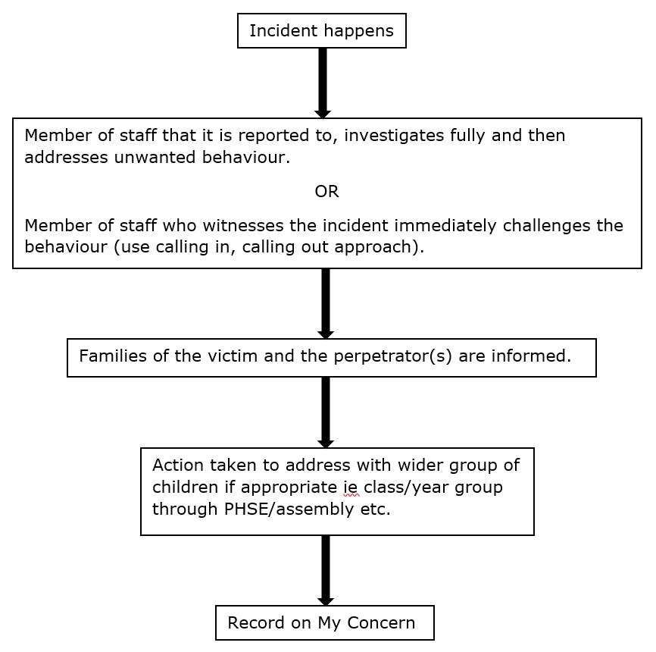

Advancing equality of opportunity
As set out in the DfE guidance on the Equality Act, BFPNS aims to advance equality of opportunity by ensuring that:
- Children’s achievement is monitored by race, gender and disability and any trends or patterns in the data that may require additional action to narrow the gap are addressed;
- There is an inclusive approach to ensuring all children are given the opportunity to make a positive contribution to the life of the school, e.g. through involvement in the School Council by election or co- option; class assemblies; fund raising etc;
- Children with disabilities can take part in all aspects of the curriculum, including educational visits and journeys; lunchtime activities; PE and dance and assemblies;
- Extended school activities such as breakfast and after-school clubs consider the needs and access issues of children attending and that they also reflect the diversity of the school population in terms of race, gender, disability and socio-economic status.

BFPNS will provide:
- Extra and additional support for children who are under-achieving, in order to make progress in their learning and their personal wellbeing, e.g. ensuring that children with visual impairment have accessible texts; that children with hearing impairment have an enhanced acoustic classroom environment;
- Additional support for parents of under-achieving children (e.g. reporting progress; discussing needs);
- Support for parents/carers who may themselves struggle with specific requirements of the school, e.g. reading documents; form filling etc;
- Additional support for disabled parents/carers and staff to help them to play a full part in the life of the school (e.g. providing a sign interpreter for a deaf parent; ensuring that meetings are held in the most accessible parts of the school to support wheelchair users etc).

Fostering good relations
The school’s aim to foster good relations between those who share a protected characteristic and those who do not share it by:
- Promoting tolerance, friendship and understanding of a range of religions and cultures through different aspects of our curriculum. This includes teaching in RE, citizenship and personal, social, health and economic (PSHE) education, but also activities in other curriculum areas. For example, as part of teaching and learning in English/reading, children will be introduced to literature from a range of cultures;
- Holding assemblies dealing with relevant issues. Children will be encouraged to take a lead in such assemblies, and we will also invite external speakers to contribute;
- Working with our local community. This includes inviting leaders of local faith groups to speak at assemblies, and organising school trips and activities based around the local community;
- Encouraging and implementing initiatives to deal with tensions between different groups of children within the school. For example, our School Council has representatives from different year groups and is formed of children from a range of backgrounds;
- All children are encouraged to participate in the school’s activities, such as after school clubs;
- We also work with parents to promote knowledge and understanding of different cultures;
- We have developed links with people and groups who have specialist knowledge about particular characteristics, which helps inform and develop our approach.

Equality considerations in decision-making
BFPNS ensures it has due regard to equality considerations whenever significant decisions are made.

The staff will always consider the impact of significant decisions on particular groups. For example, when a school trip or activity is being planned, the School considers whether the trip:
- Cuts across any religious holidays;
- Is accessible to children with disabilities and those from lower socio-economic backgrounds;
- Has equivalent facilities for boys and girls.

Equality objectives
We understand the principle of the Act and the work needed to ensure that those with protected characteristics are not discriminated against and are given equality of opportunity. A protected characteristic under the act covers the groups listed below:
- age
- disability
- gender reassignment
- marriage and civil partnership
- pregnancy and maternity
- race
- religion or belief
- sex and sexual orientation

To do this we will collect data related to the protected characteristics above and analyse this data to determine our focus for our equality objectives. The data will be assessed across our core provisions as a school. This will include the following functions:
- Admissions
- Attendance
- Attainment
- Exclusions
- Prejudice related incidents

Objective | Why? | Action
To ensure that children, regardless of race, socio-economic status, gender and disability and particularly those supported through additional funding (PP and SEND) receive appropriate targeted support. | To help children to address any previous underachievement and to reach their potential in academic and pastoral areas of education. | HT, Pupil Premium Lead and SENDCO to challenge teachers to understand who their underachieving children, particularly the PP and SEND children, are and hold them account for developing provision, accessibility and scaffolding to support these children to achieve well.
To raise equality awareness with students and staff, ensuring tolerance and respect towards individuals who identify with any of the protected characteristics. | To help foster good relationships across all characteristics between people who share a protected characteristic and people who do not share it by having the need and regard to tackle prejudice and promote understanding. | Children are proactively taught about the attitudes, resources, provision and experiences of the diverse population of the UK/world, and these are reflected in the curriculum, assemblies and school events. See assemblies’ agenda for details.
To ensure that school promotes role models and heroes that young people positively identify with, who reflect and broaden the school’s diversity in terms of race, gender and disability etc. | To ensure that children have examples of people from diverse backgrounds and abilities to inspire, motivate and help shape their character and personality as they grow. To help children to recognise appropriate behaviour and try to acquire admirable qualities by seeing examples of successful people from all walks of life. | Display examples of successful people prominently on notice boards throughout the school. Ensure that teachers are using a wide variety of examples of role models in their lessons, engaging in positive discussions on diversity and promoting the idea that it is possible for everyone to achieve their goals in life regardless of race, gender or disability. Assemblies promoting the rights respecting values and equal opportunities ethos of the school and displaying examples of these as constant reminders throughout the school.

Monitoring arrangements
We continue to make regular assessments of children’ learning and use this information to track pupil progress. As part of this process, we regularly monitor achievement by ethnicity, gender and disability, to ensure that all groups of children are making the best possible progress and use this to inform strategies to raise achievement.

Links with other policies
This document links to the following policies:
- Accessibility plan
- Child Protection

